**Claw Assignment By lekhraj jadon**

**Set up Azure Virtual Machines** to host the front-end and back-end services.

* + Use two separate Linux VMs (one for the front end, one for the back end).

**Set up Azure Virtual Machines to host the front-end and back-end services:** Provision two Azure Virtual Machines (VMs) to separate front-end and back-end services. Utilize one VM for hosting the front-end, such as a web server, and another for the back-end, which handles business logic and data processing

ssh -i frontend_public_key.pem [azureuser@52.149.234.232](mailto:azureuser@52.149.234.232)

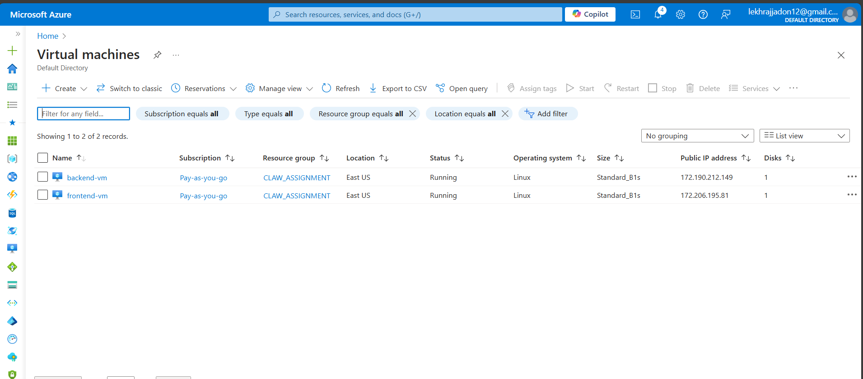

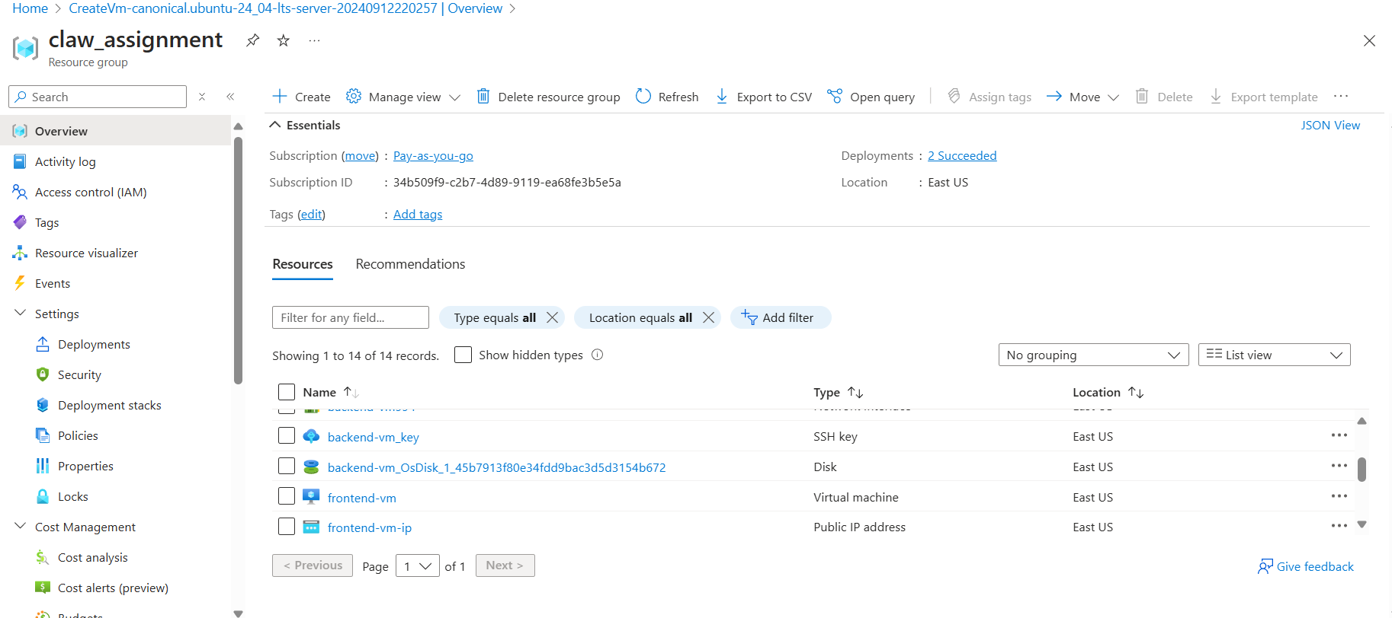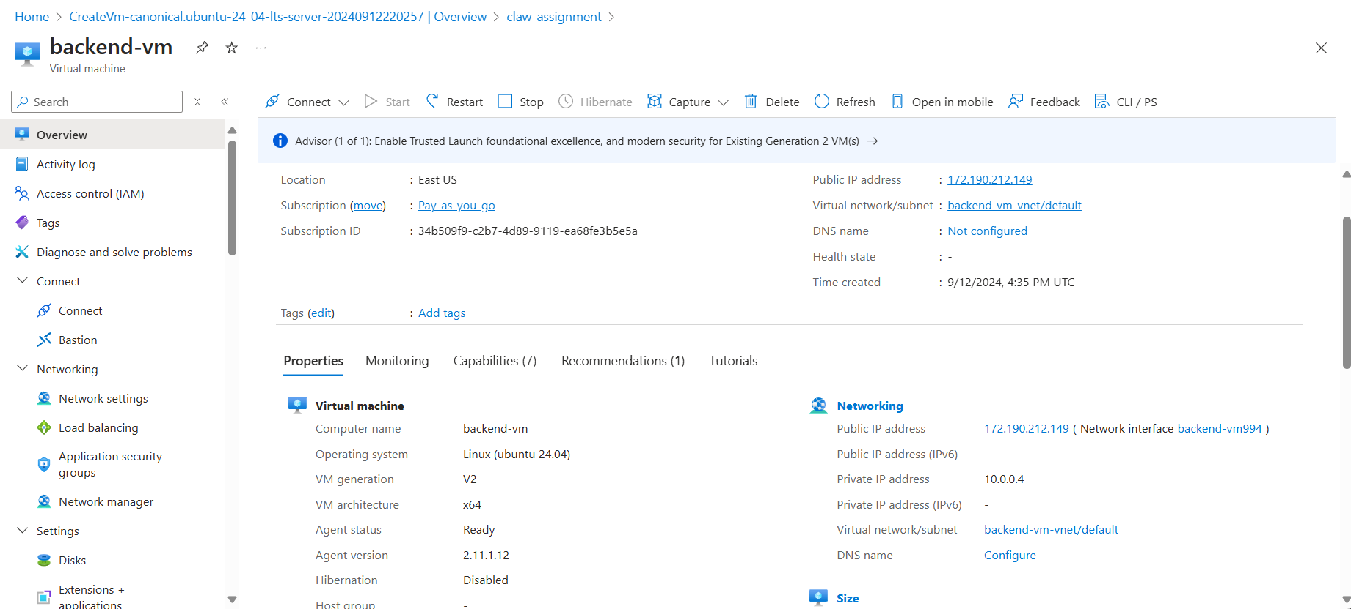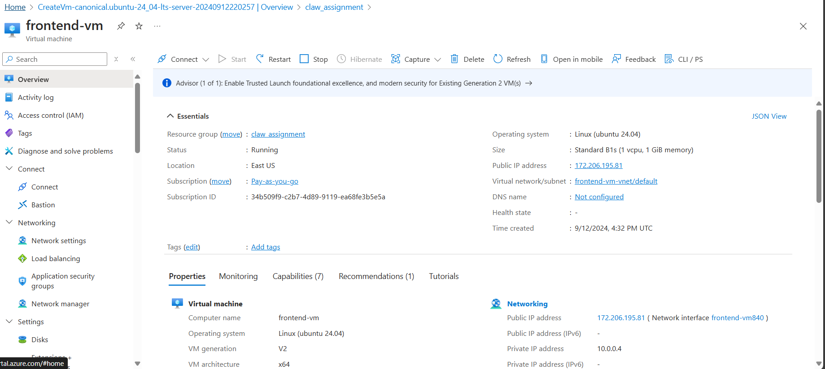

1. **Dockerize the front-end and back-end applications**.
   * The front-end can be a simple NGINX server hosting a static HTML page.
   * The back-end can be a Node.js API.

**Dockerize the front-end and back-end applications:** Dockerizing applications involves encapsulating them into containers, which simplifies deployment and scaling. For the front-end, use an NGINX container to serve static HTML pages efficiently. For the back-end, deploy a Node.js container to manage API requests, ensuring that both services run in isolated environments with consistent configurations across different systems.

docker build -t frontend-image .

docker run -d -p 80:80 frontend-image

**docker run -d -p 80:80 frontend-image**

**docker build -t backend-image .**

**docker run -d -p 8000:8000 backend-image**

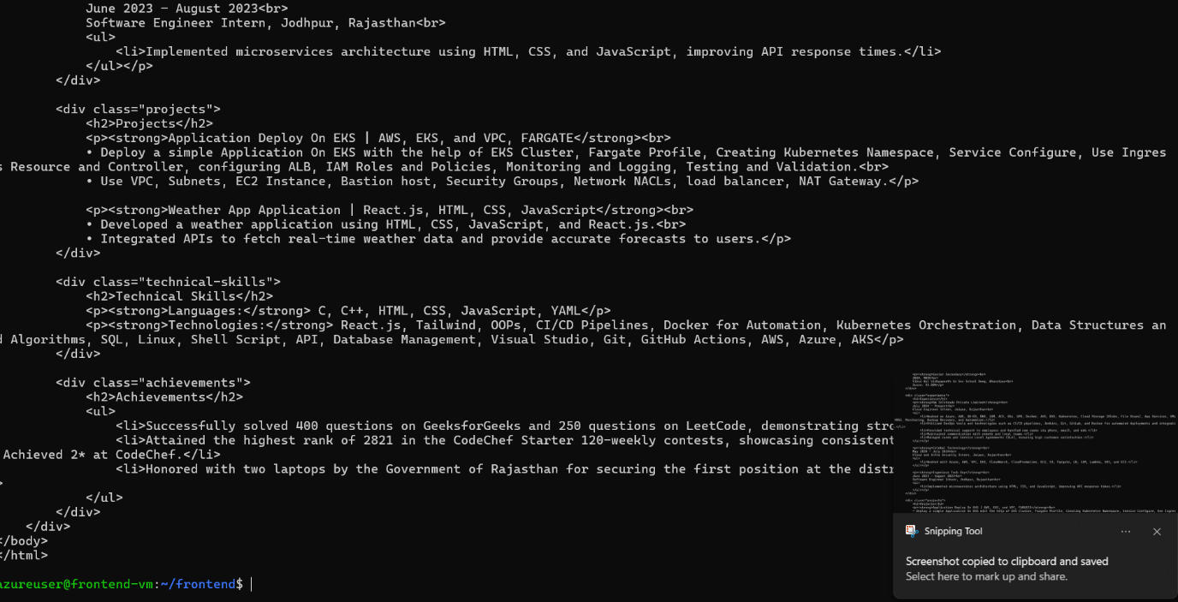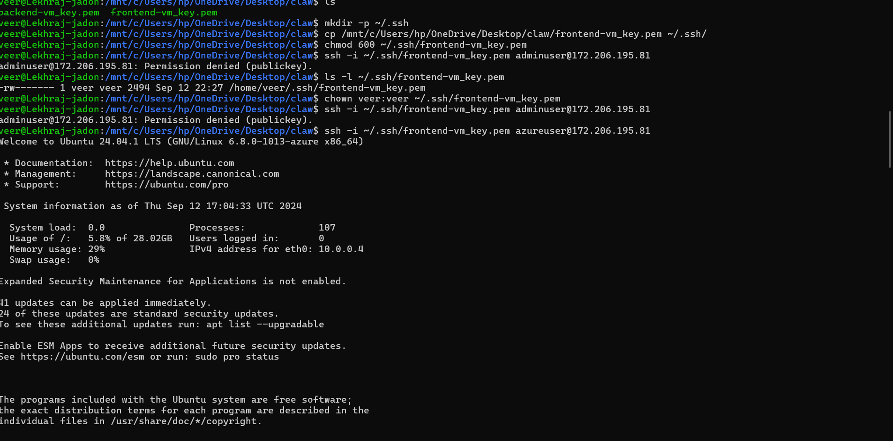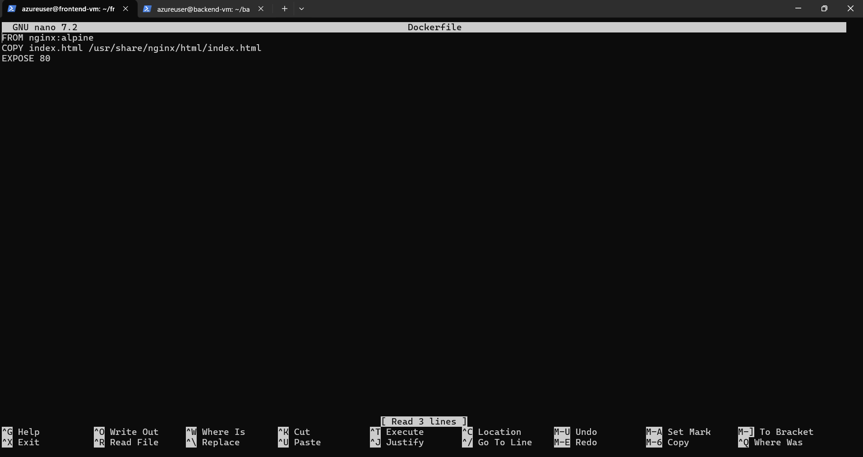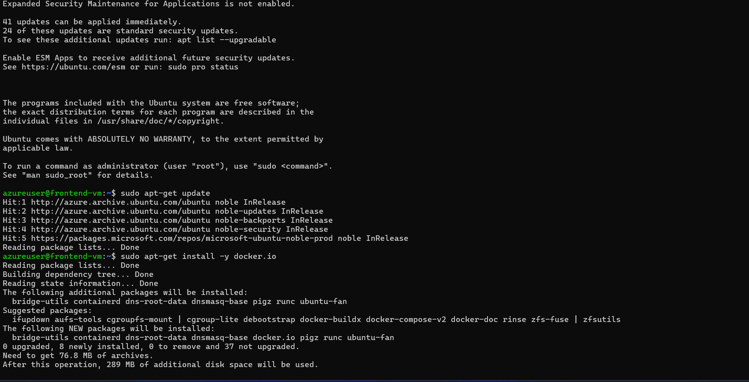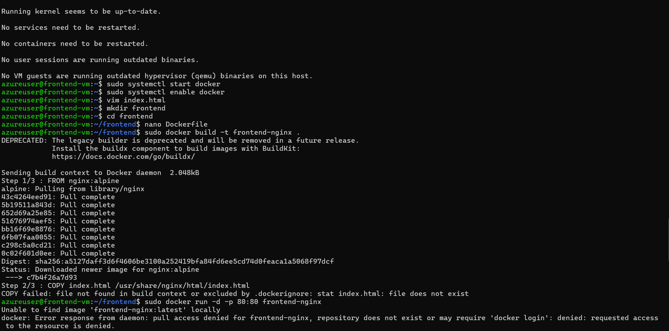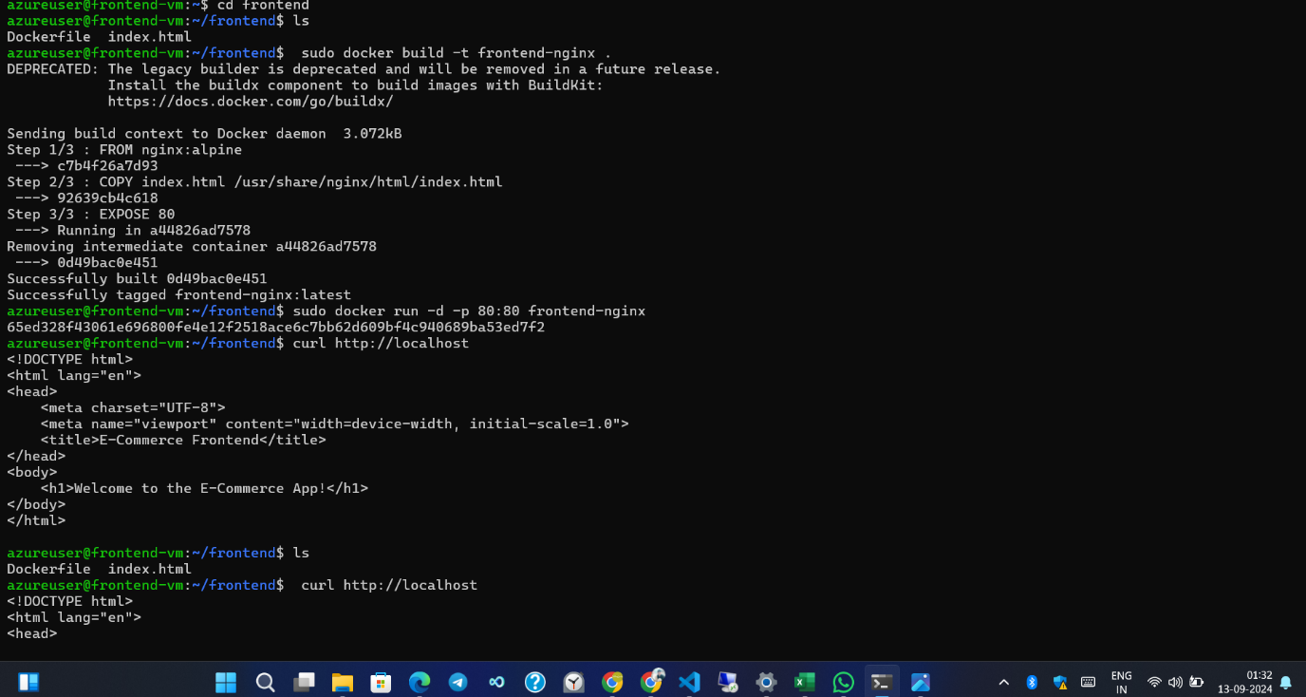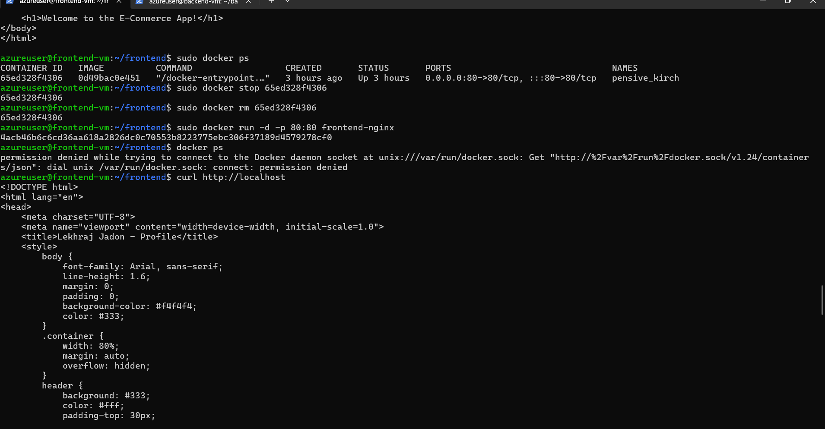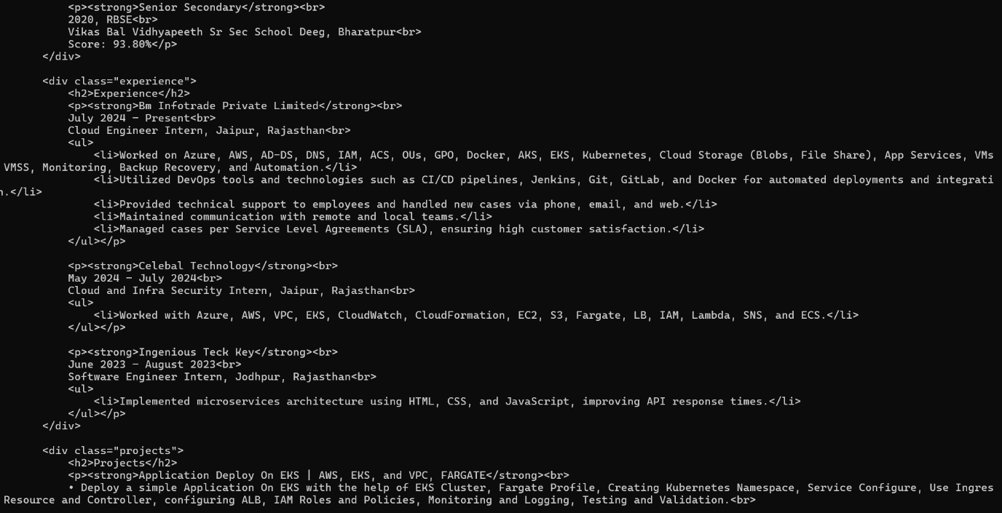

Docker File For INGINX



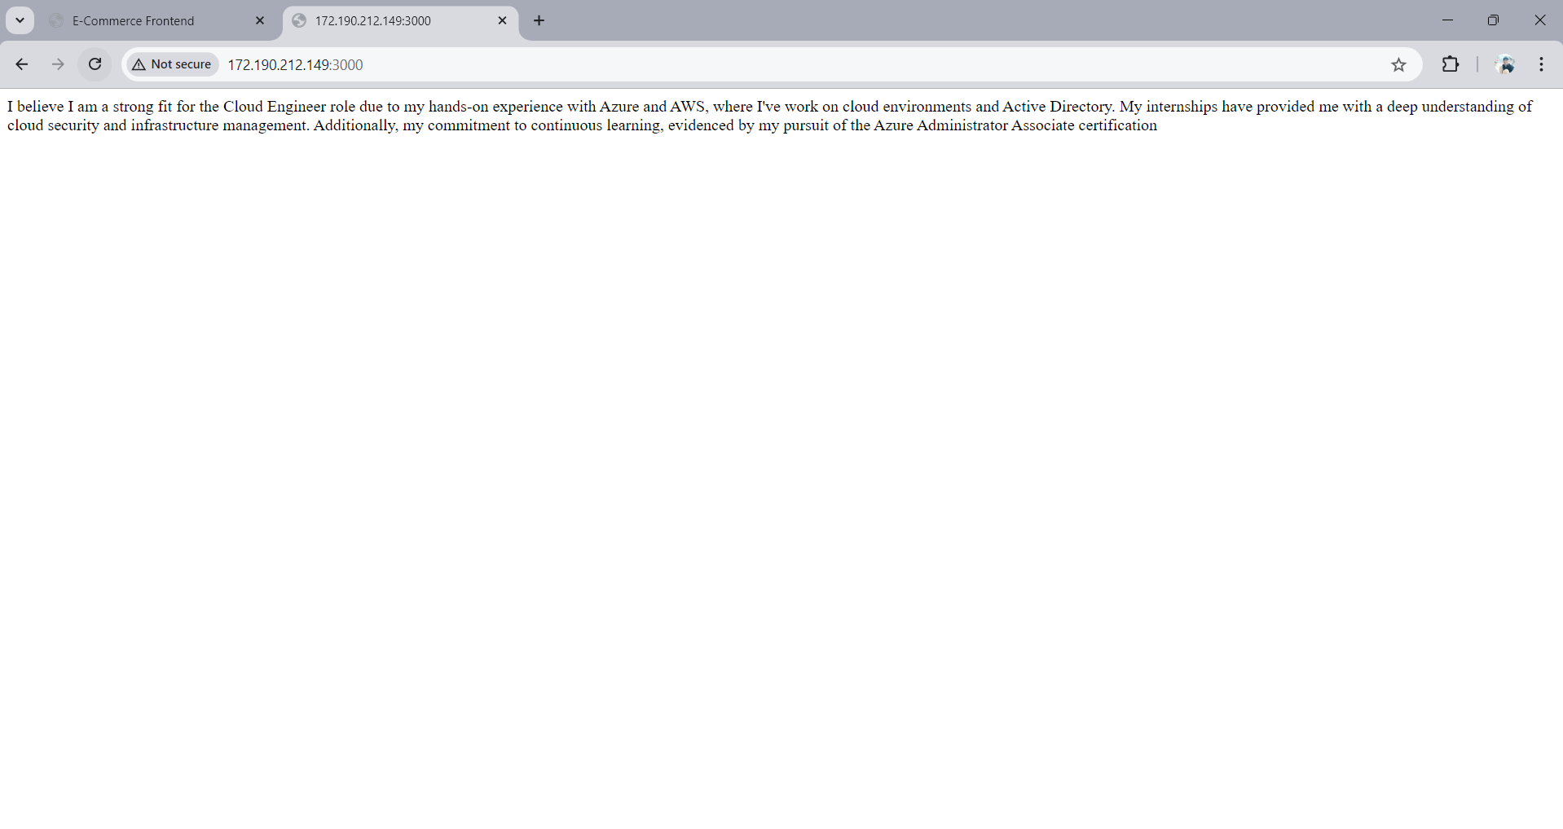

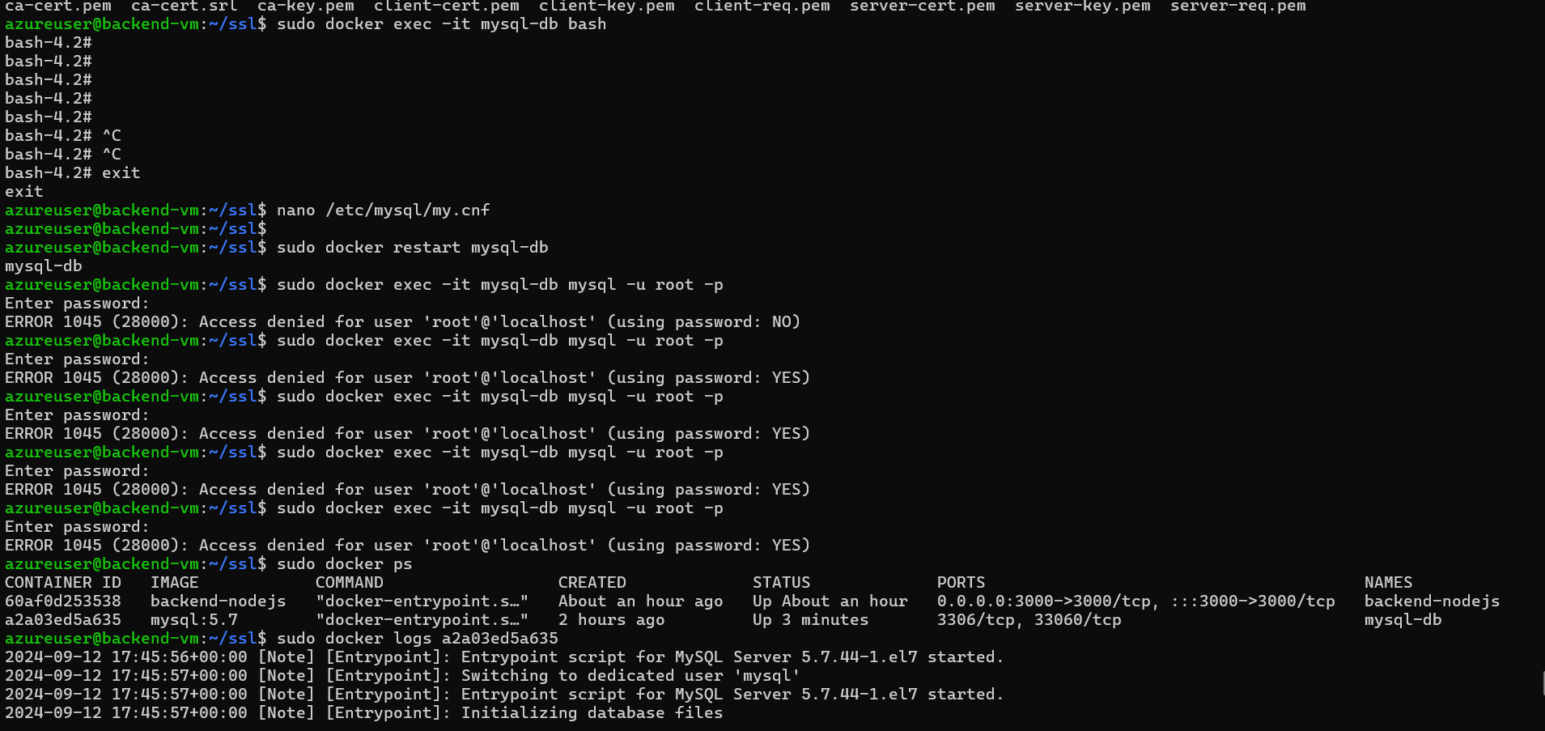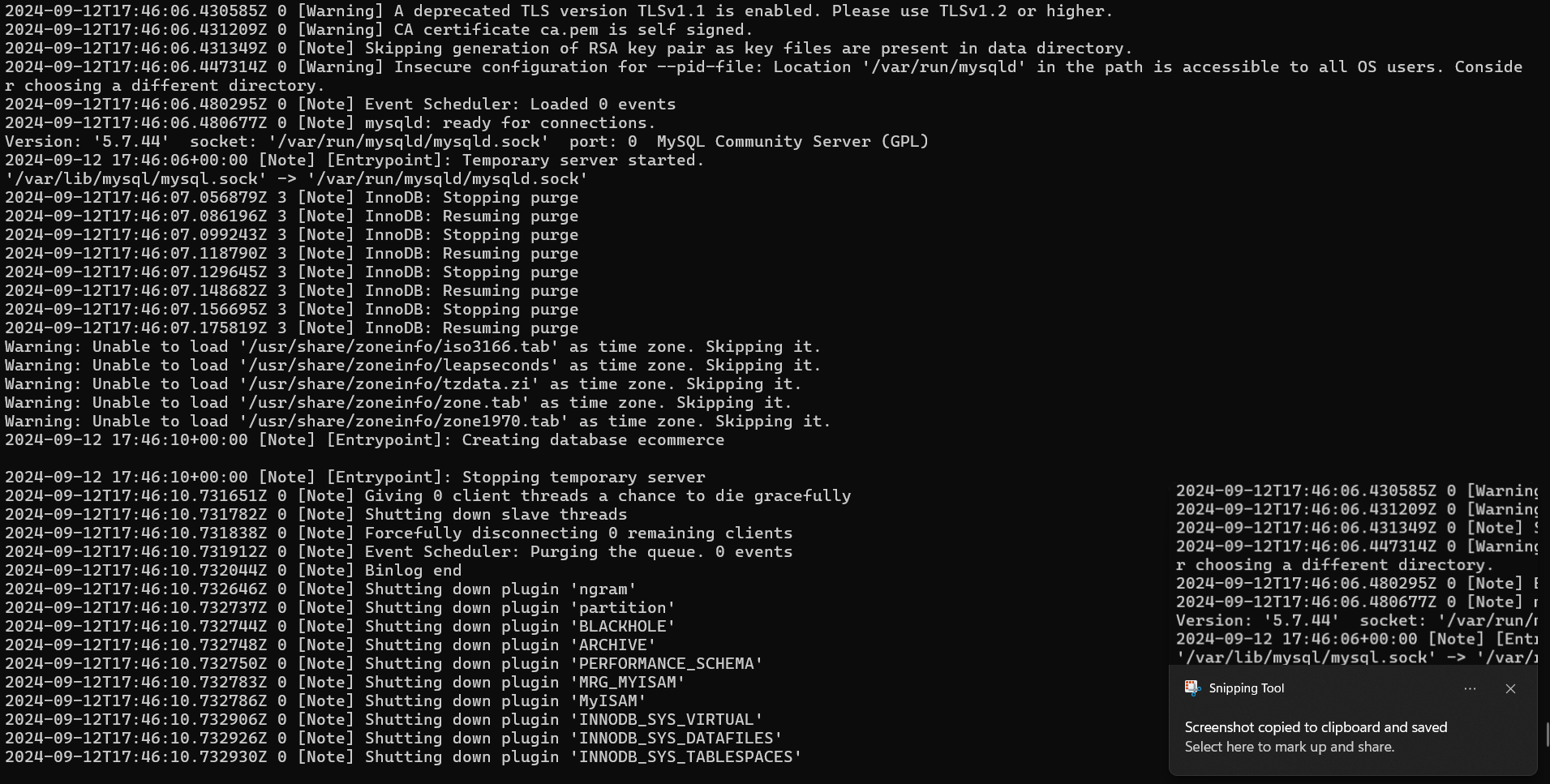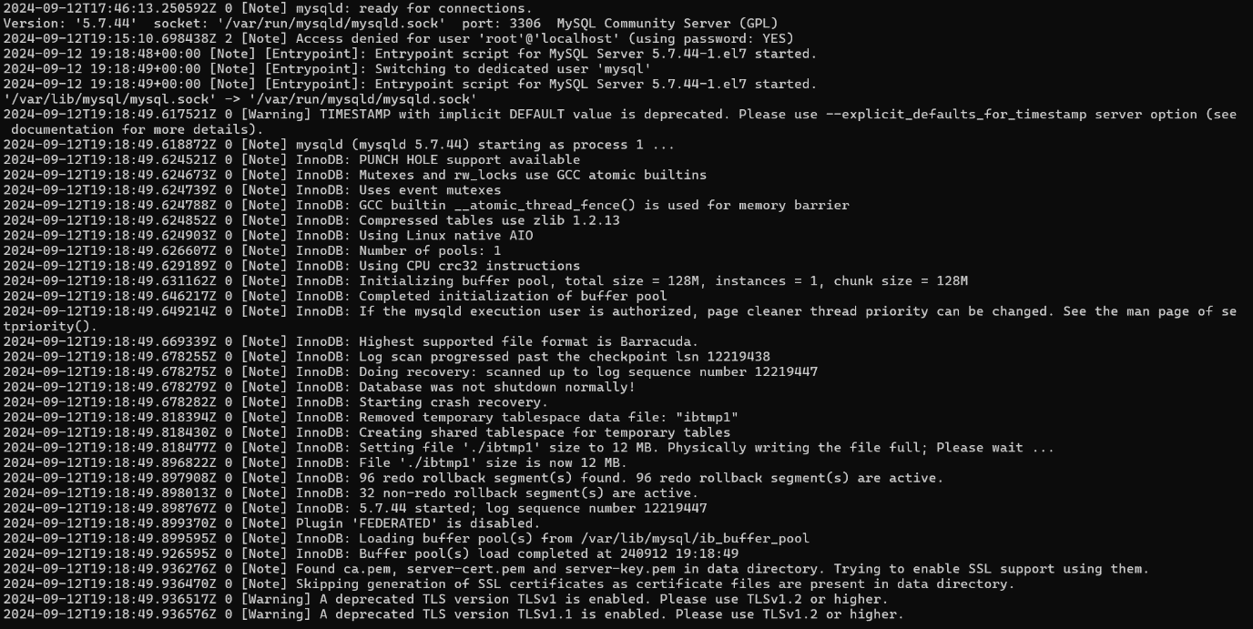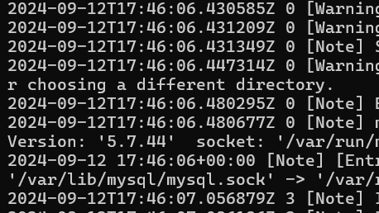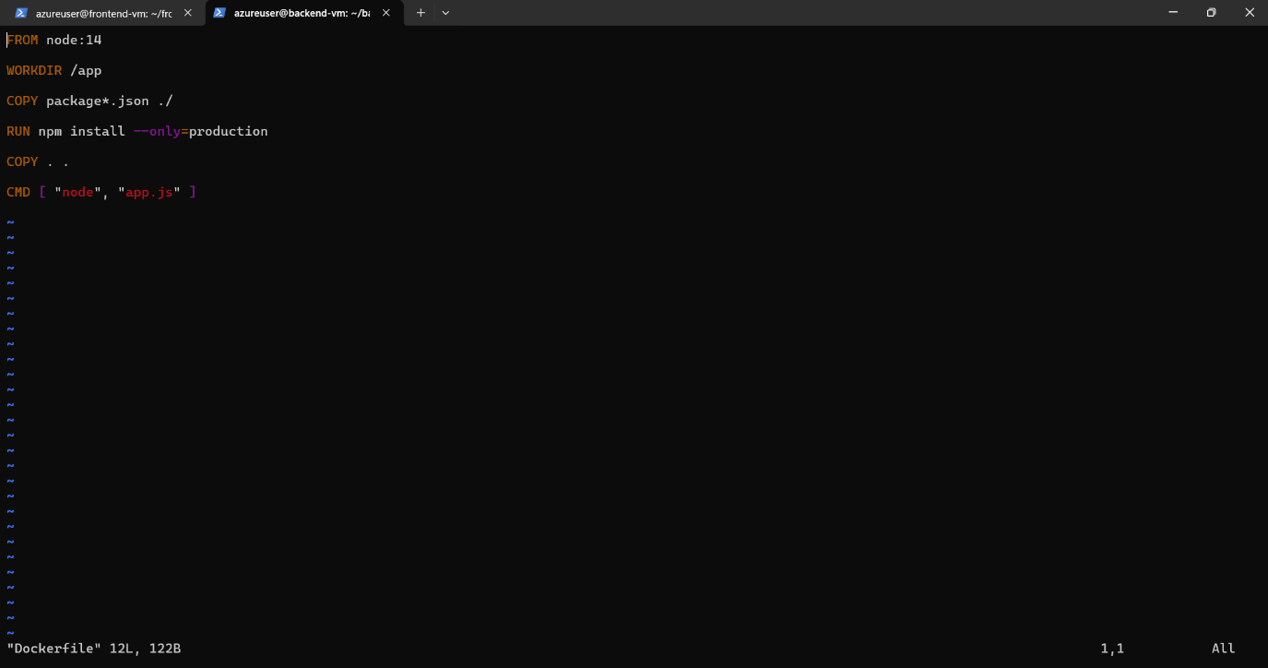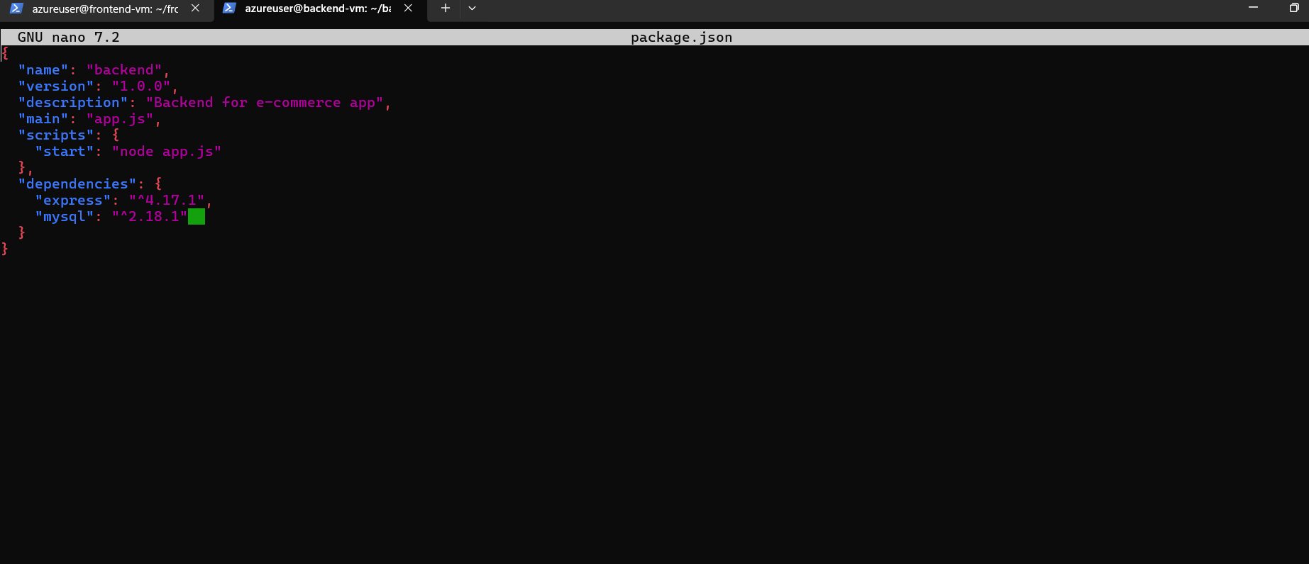

1. **Deploy a MySQL database** using Docker on the back-end VM.

**Deploy a MySQL database using Docker on the back-end VM: Deploying MySQL in a Docker container on the back-end VM isolates the database from the host environment, enhancing portability and ease of management. This approach allows for quick deployments and version control while maintaining a consistent database environment across development, testing, and production stages.**

**docker pull mysql:latest**

**docker run -d -p 3306:3306 --name mysql-db -e MYSQL_ROOT_PASSWORD=<password> mysql:latest**

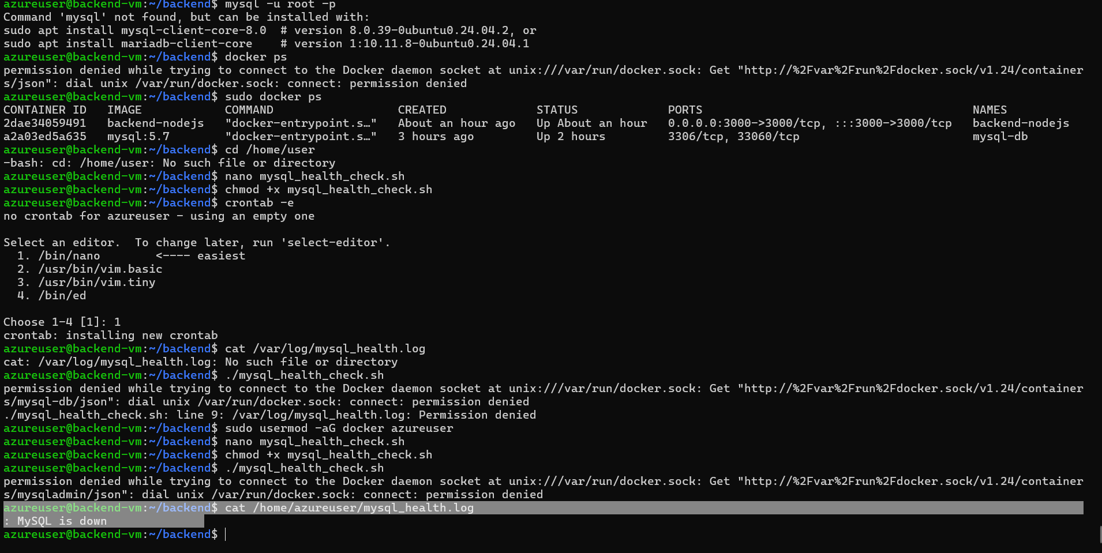

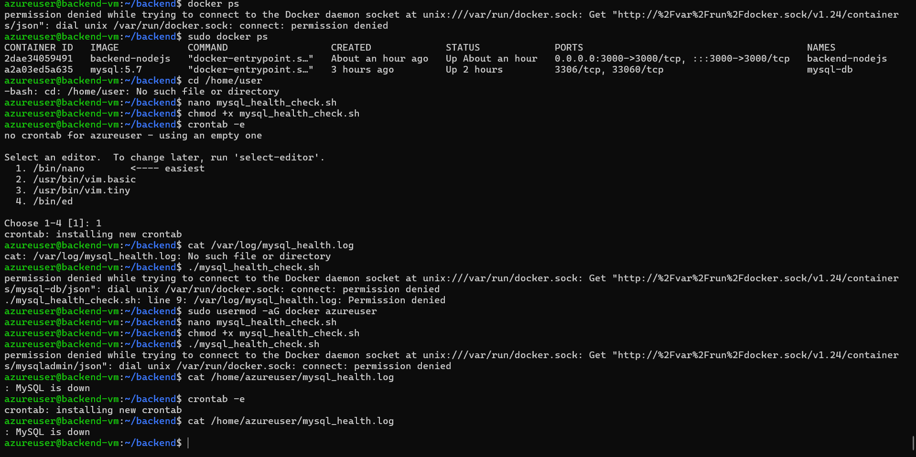

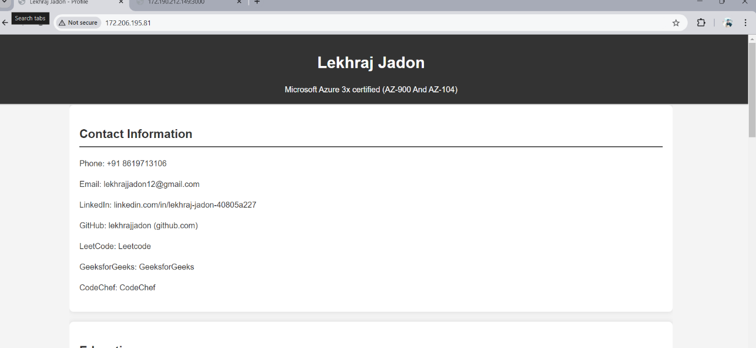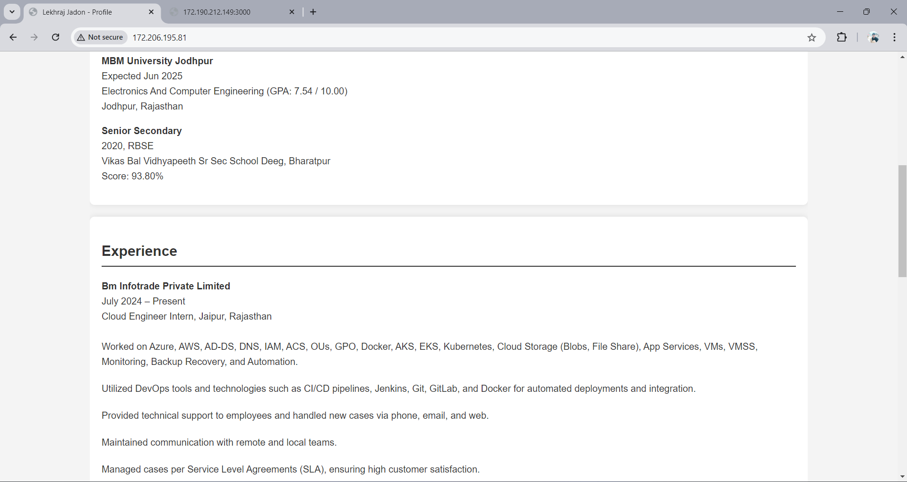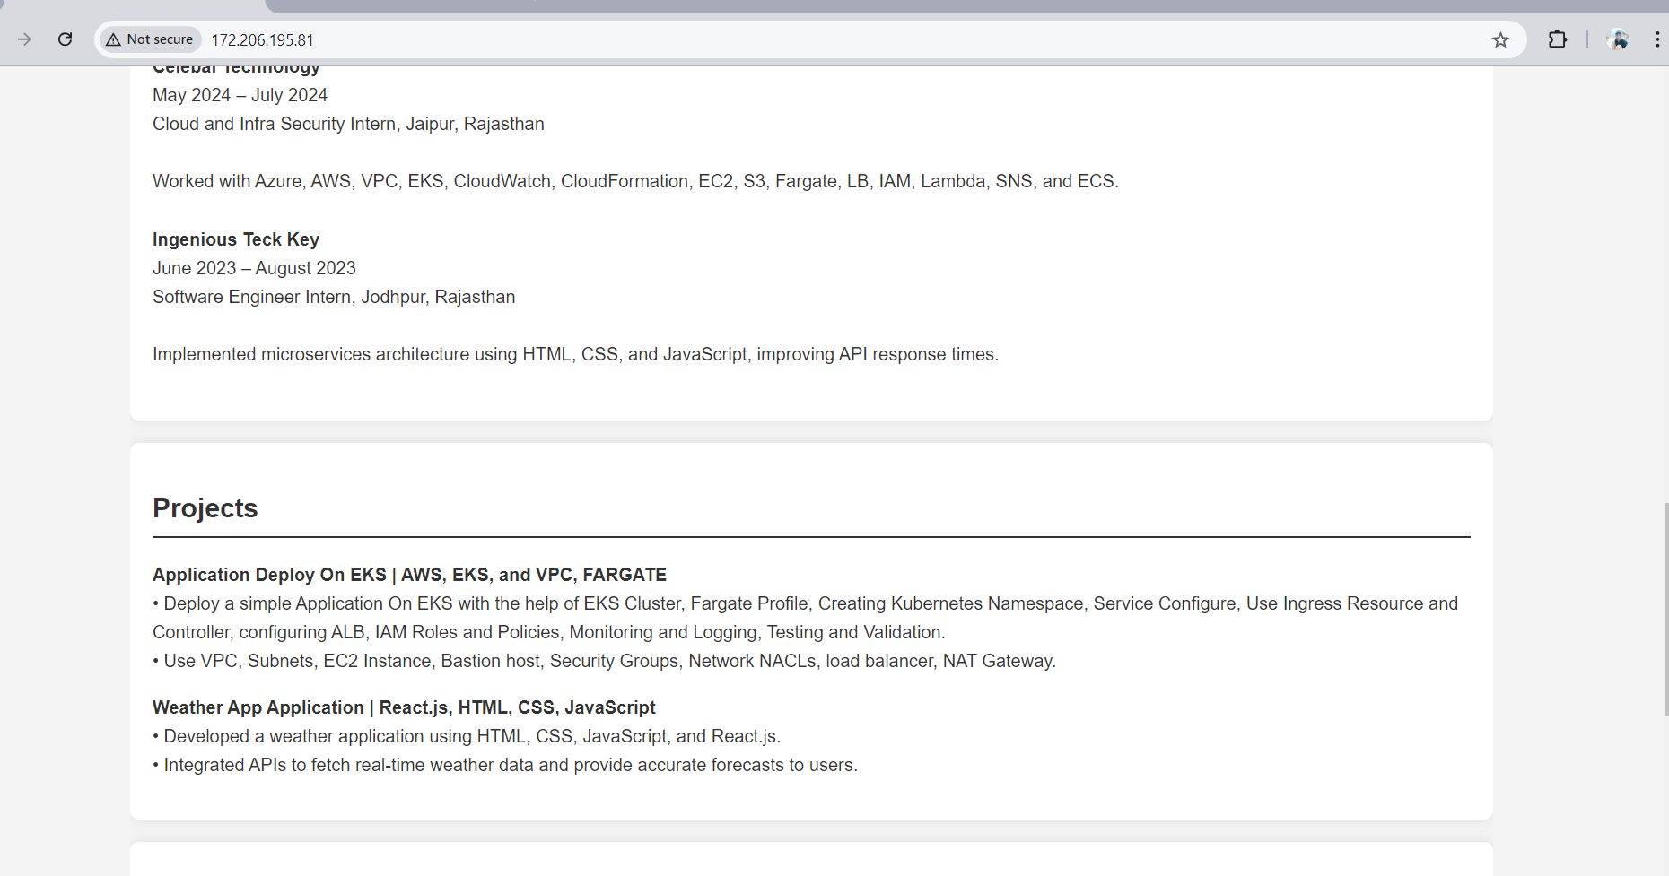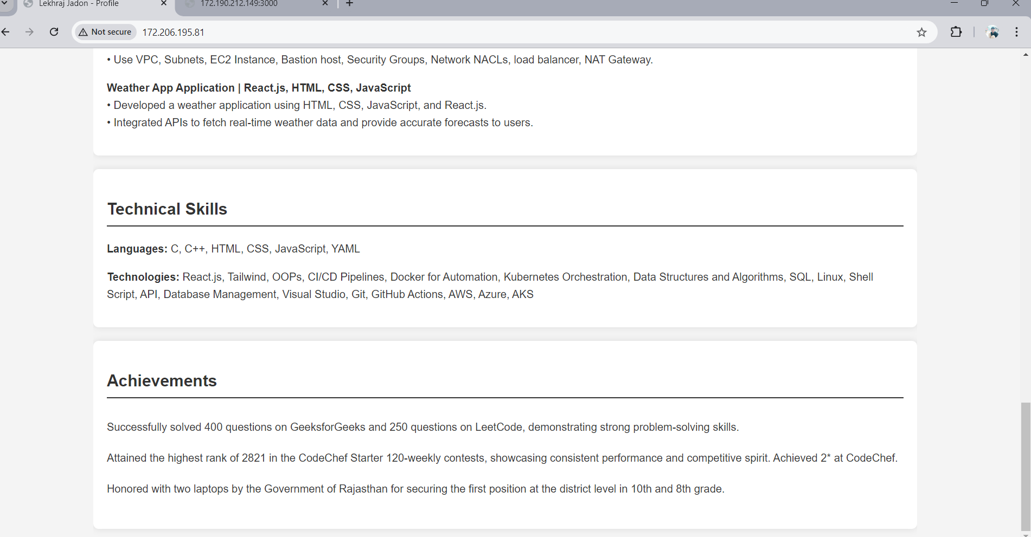

1. **Ensure database integration** between the back-end API and the MySQL database, securing communication using SSL.
2. • **Ensure database integration between the back-end API and the MySQL database, securing communication using SSL:** Integrate the Node.js API with the MySQL database by configuring the database connection within the API code. Implement SSL/TLS to encrypt data transmitted between the API and the database, ensuring secure data communication and protecting sensitive information from interception and tampering.

Mkdir my.cnf

[mysqld]

ssl-ca=/path/to/ca-cert.pem

ssl-cert=/path/to/server-cert.pem

ssl-key=/path/to/server-key.pem

update node.js

const mysql = require('mysql');

const connection = mysql.createConnection({

host: 'localhost',

user: 'root',

password: '<password>',

database: '<database>',

ssl: {

ca: fs.readFileSync('/path/to/ca-cert.pem')

}

});

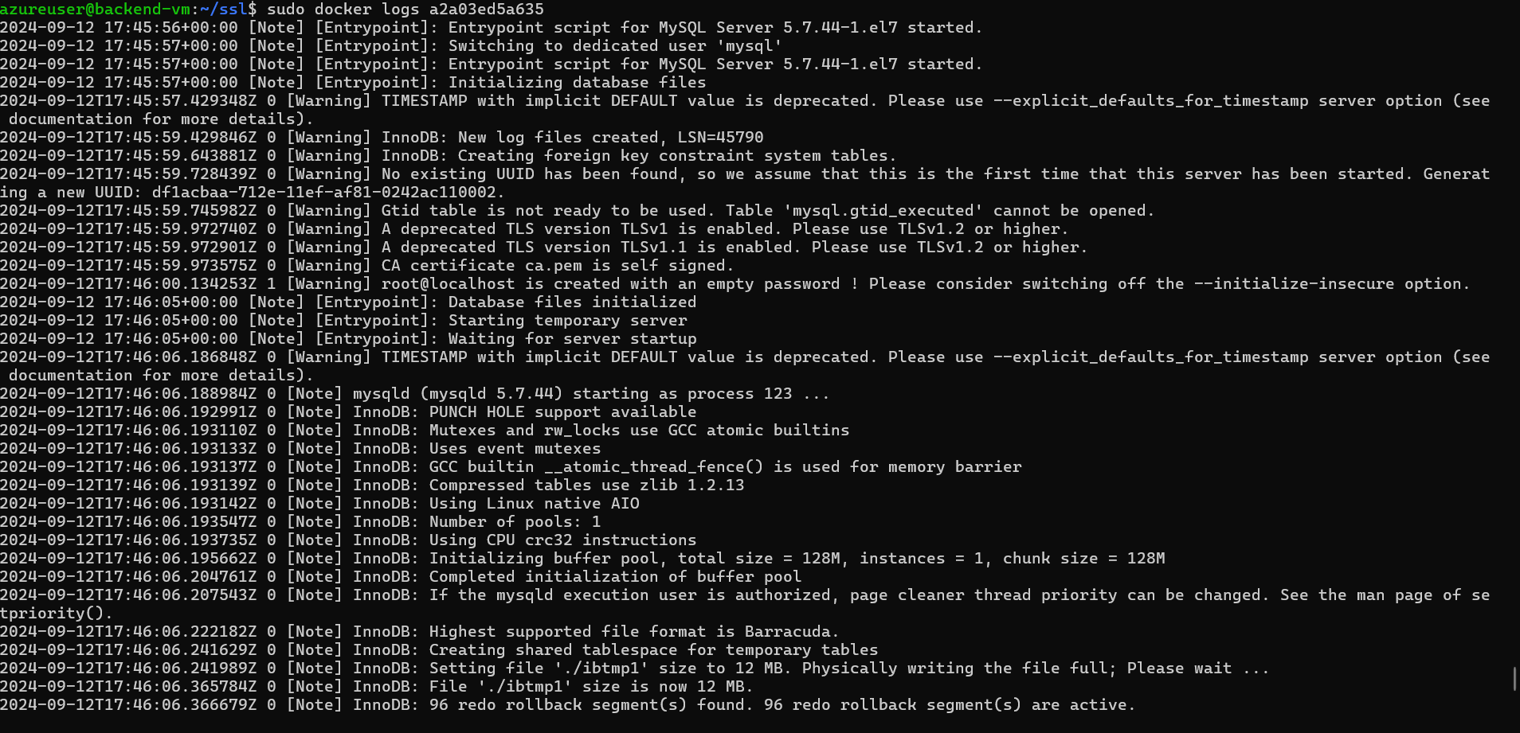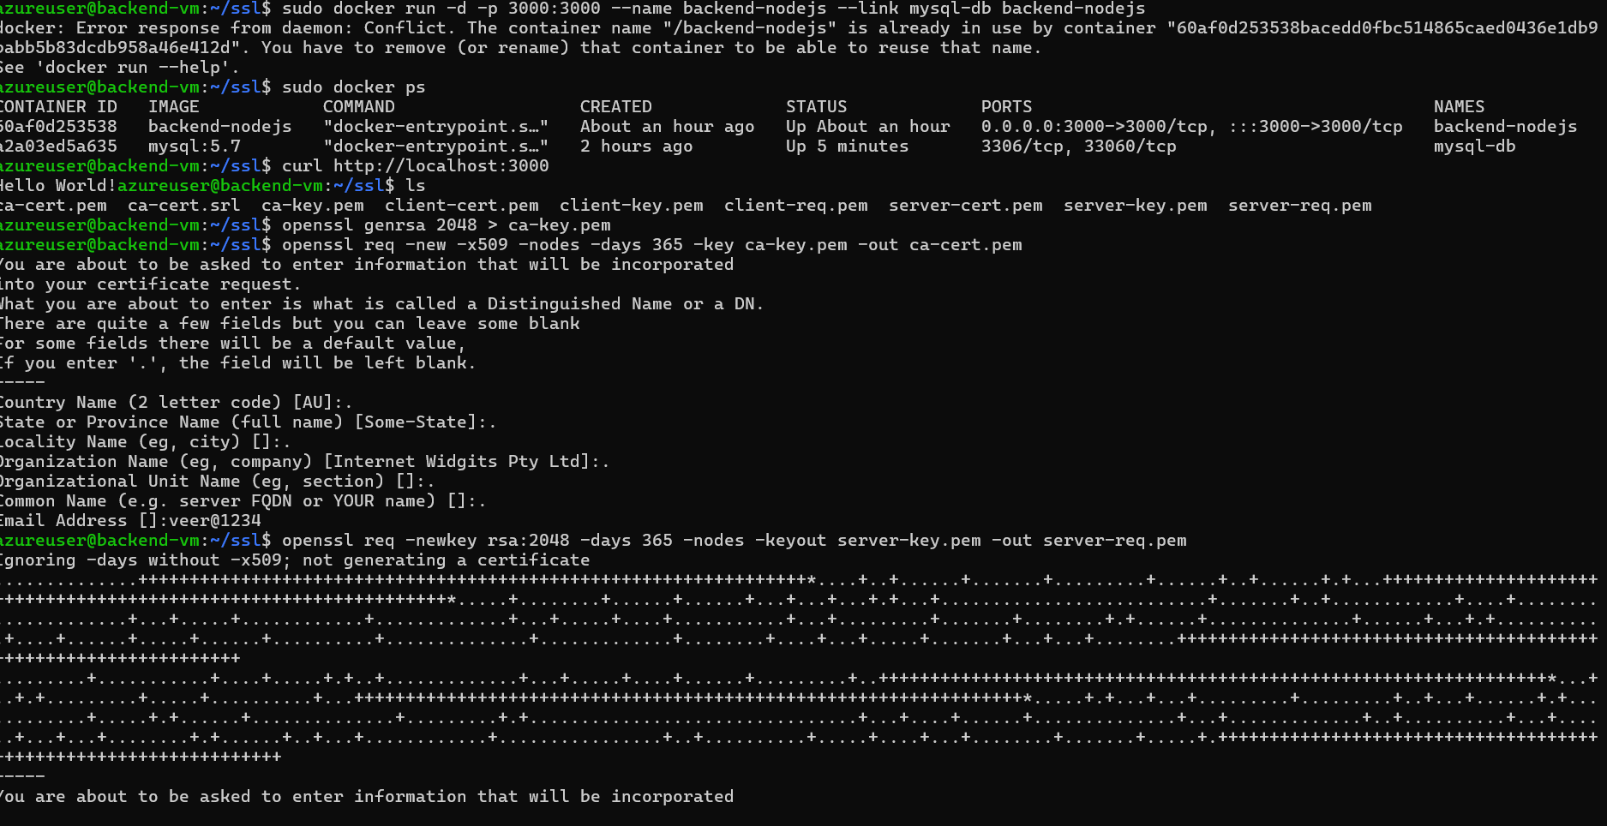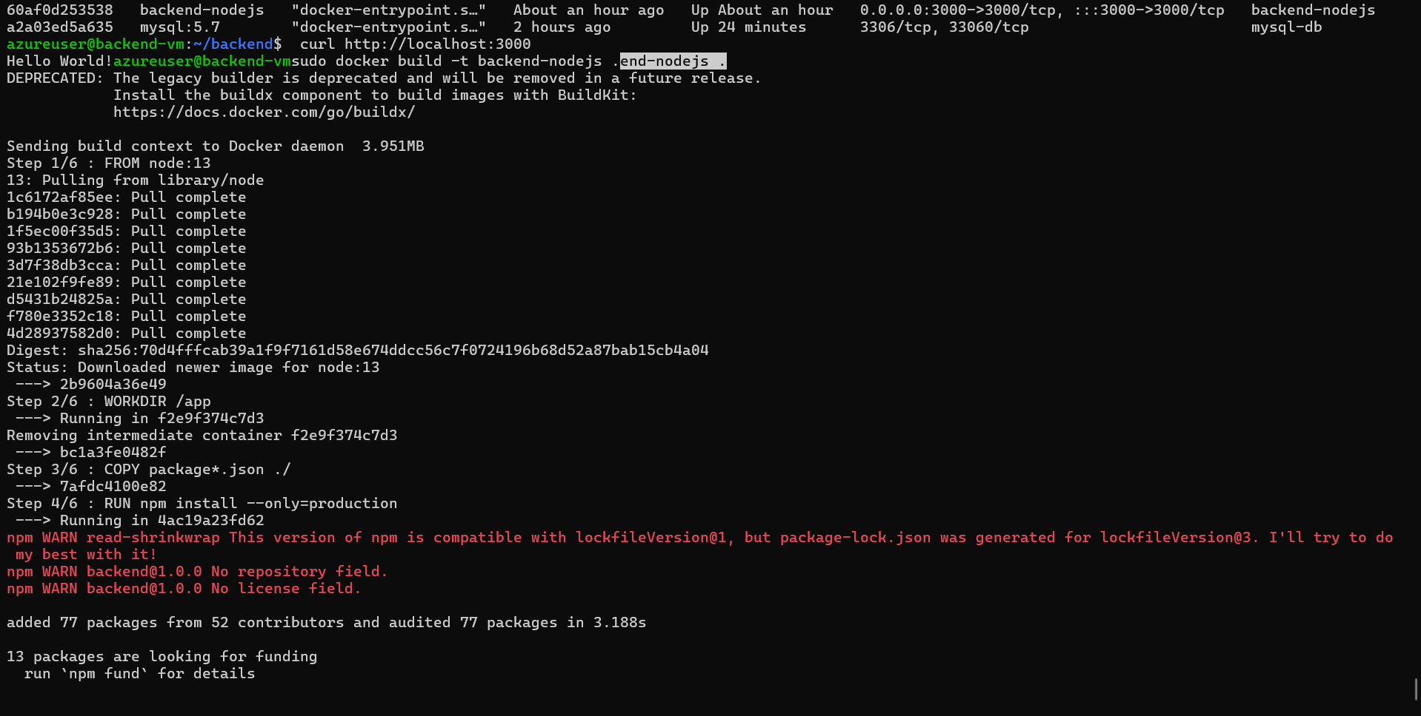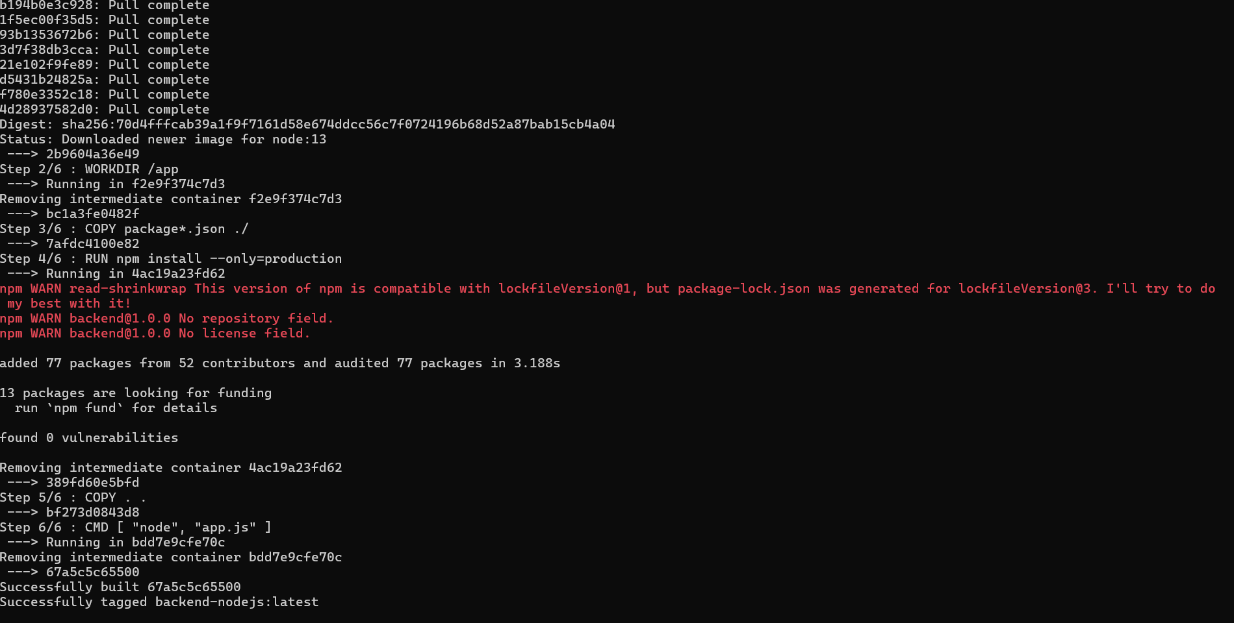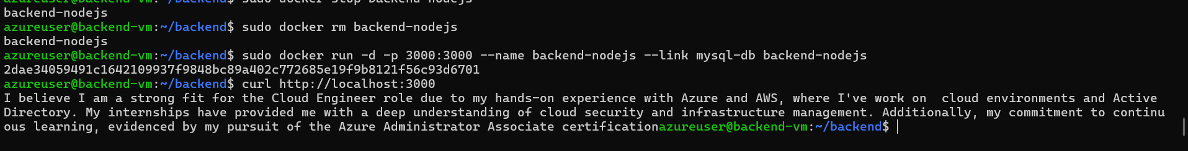

1. Set up **Azure Load Balancer** to distribute traffic between the front-end and back-end VMs for high availability.

**Set up Azure Load Balancer to distribute traffic between the front-end and back-end VMs for high availability:** Configure Azure Load Balancer to distribute incoming traffic evenly between the front-end and back-end VMs. This setup enhances application availability and reliability by balancing the load, preventing any single VM from becoming a bottleneck, and ensuring uninterrupted service in case of VM failures.

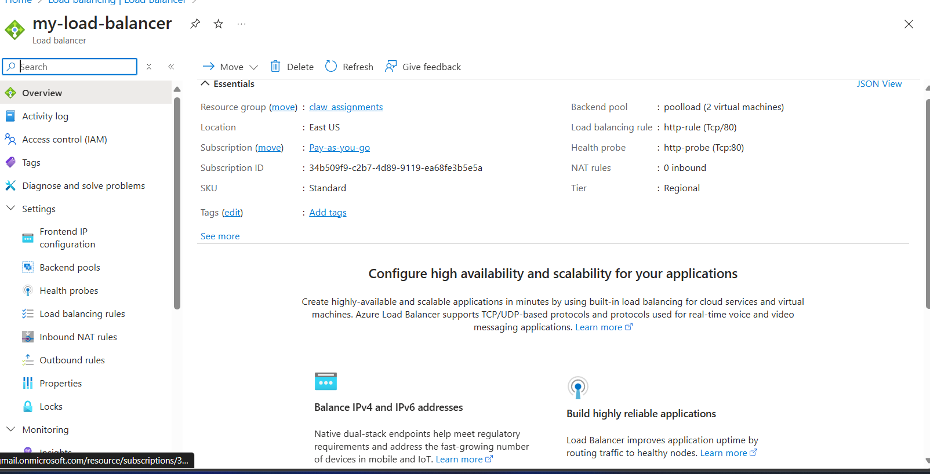

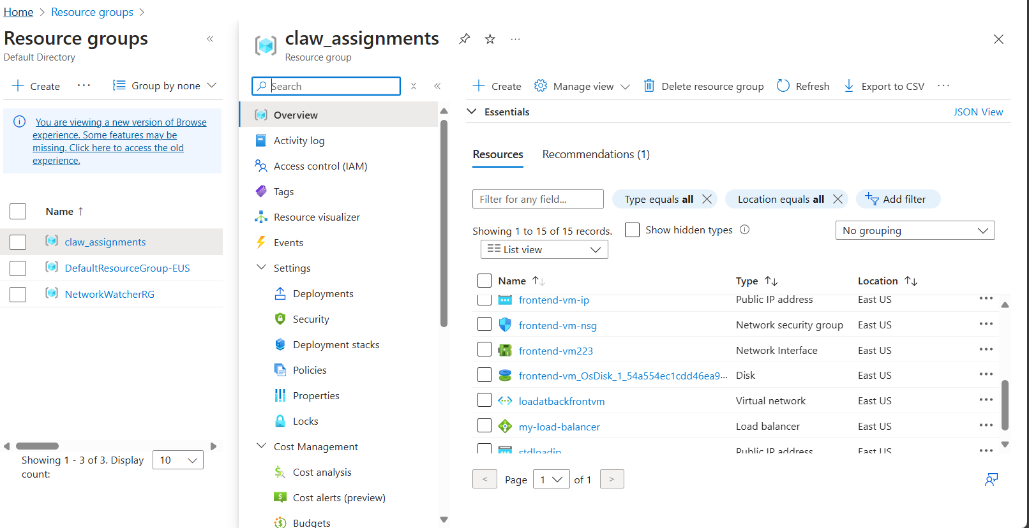

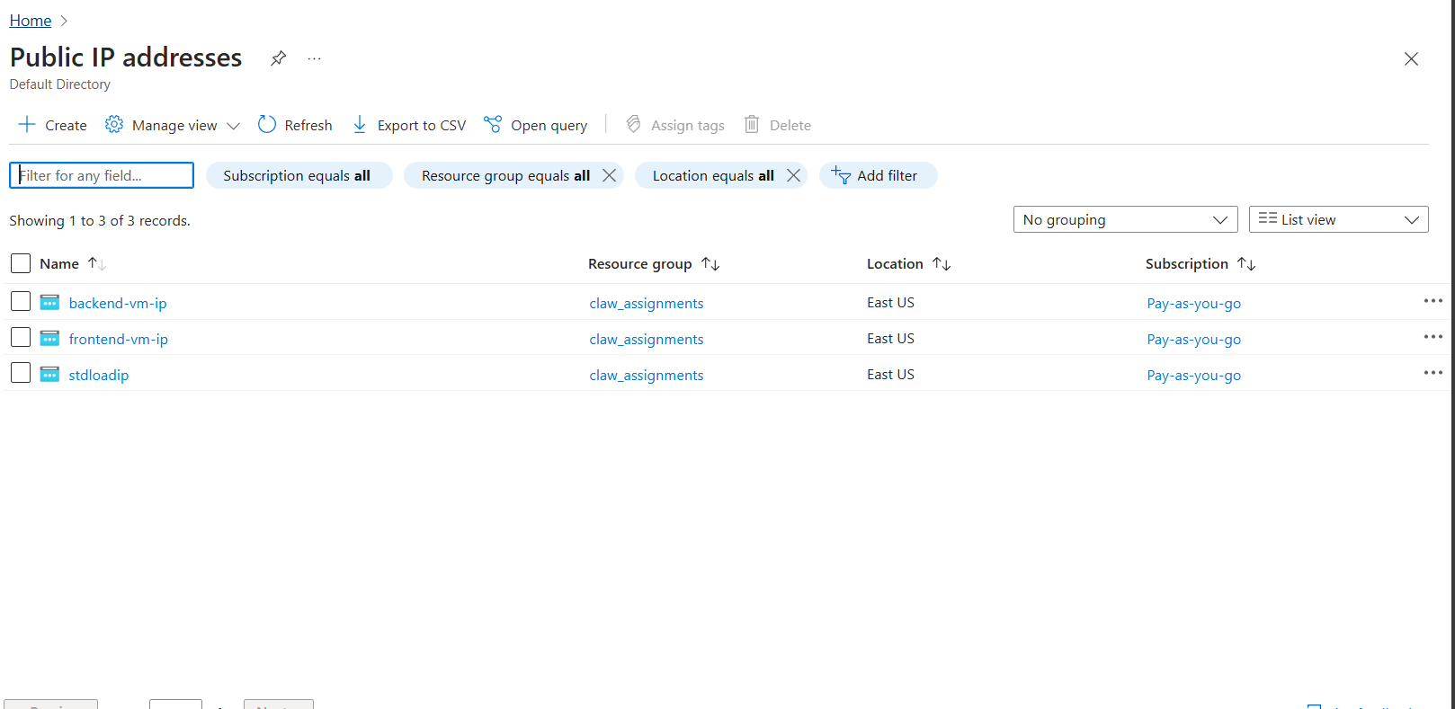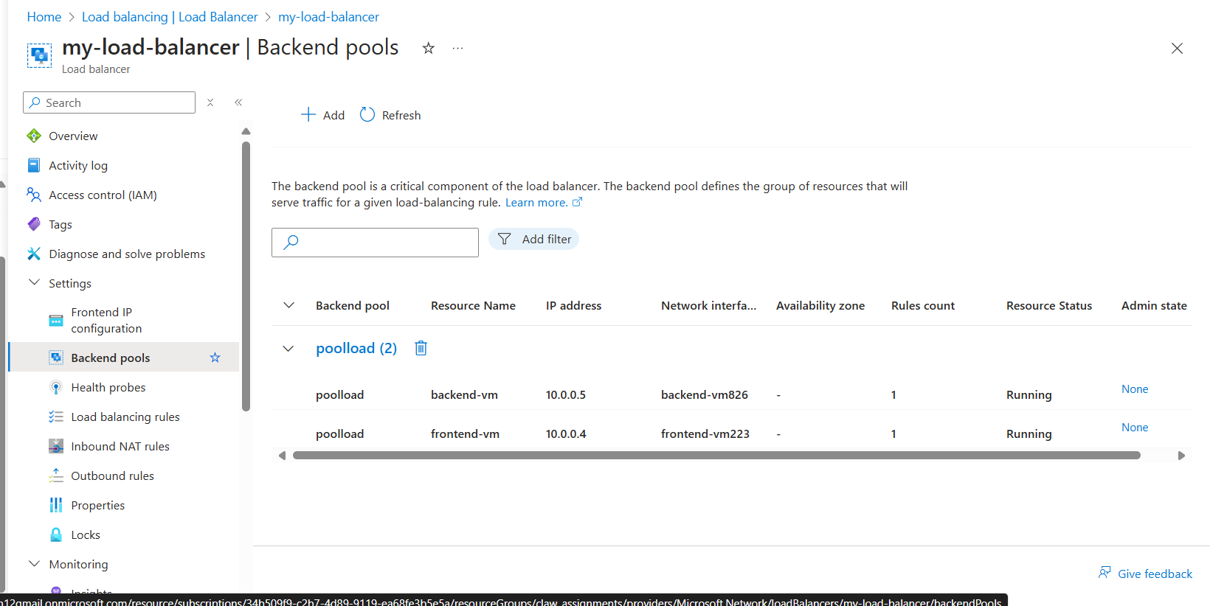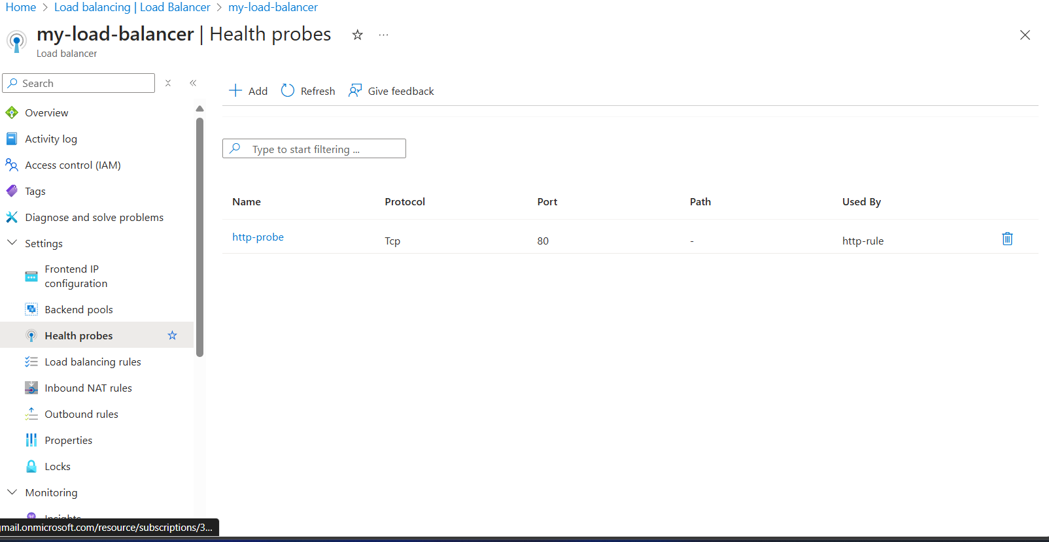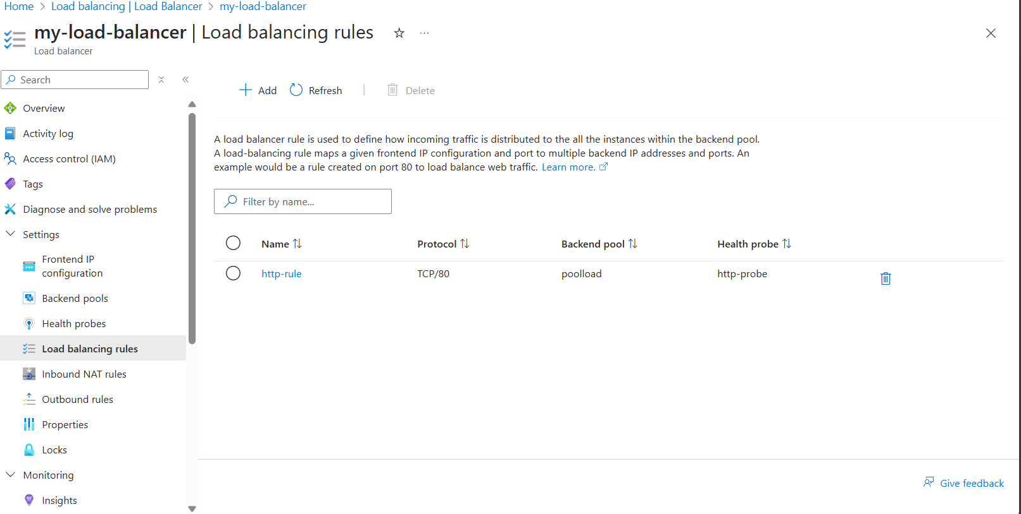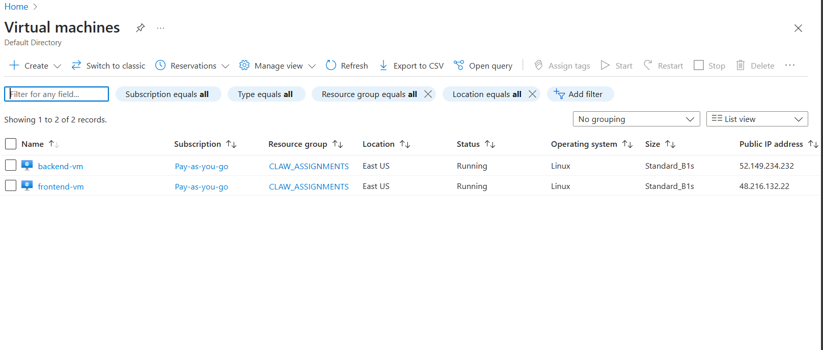

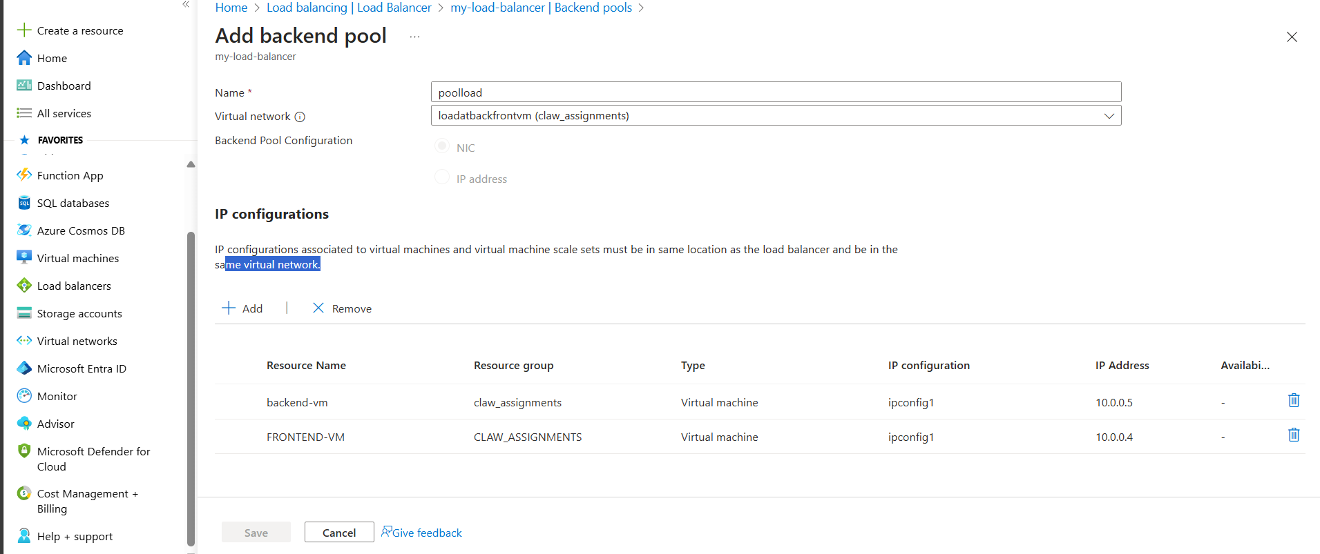

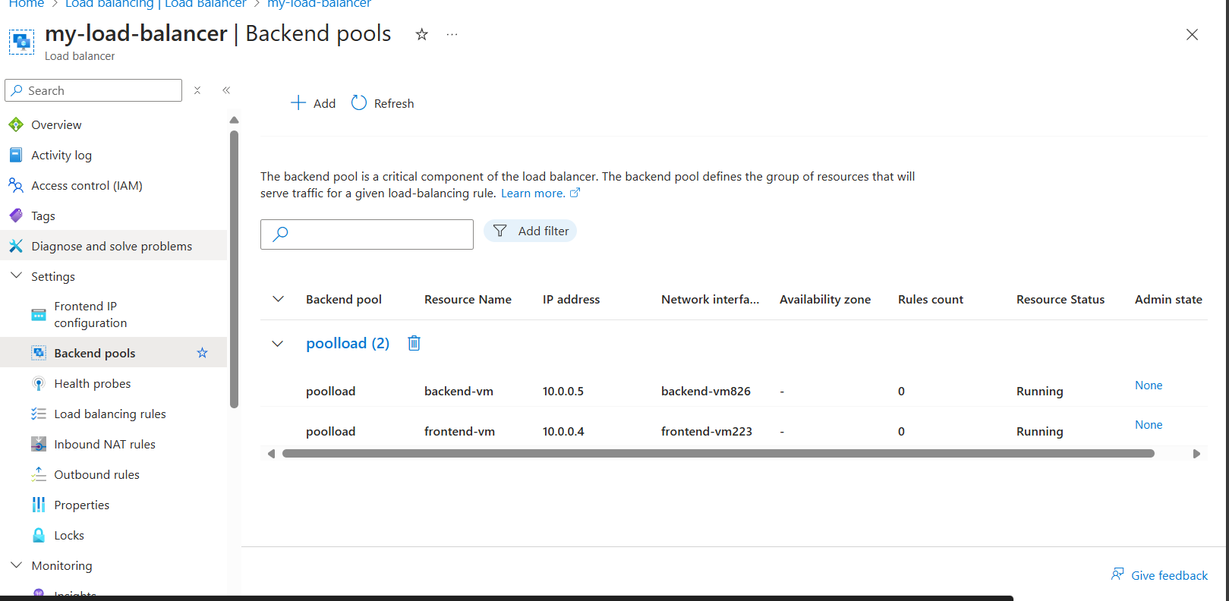

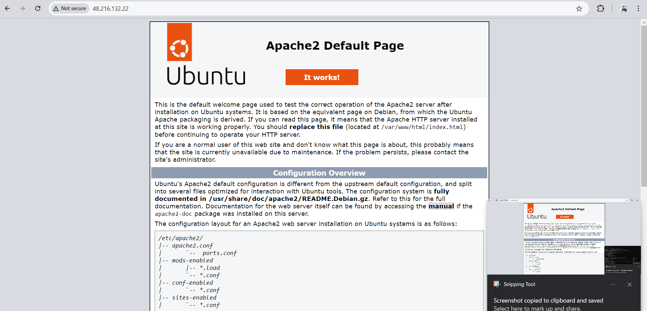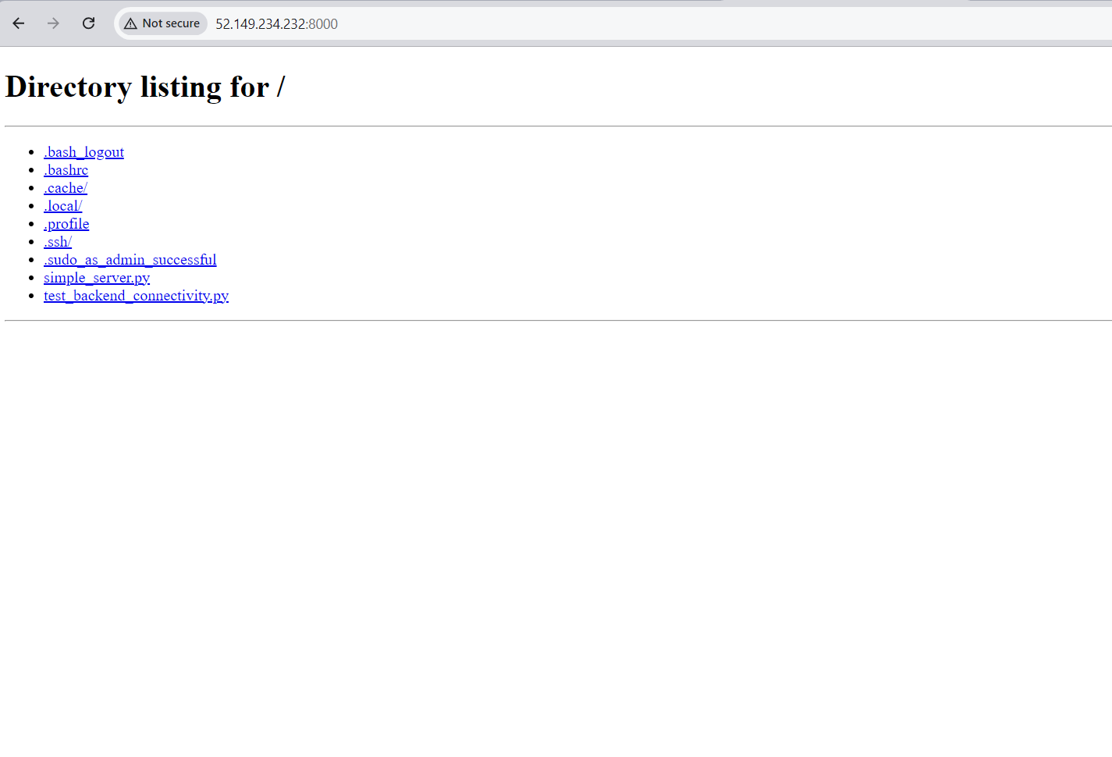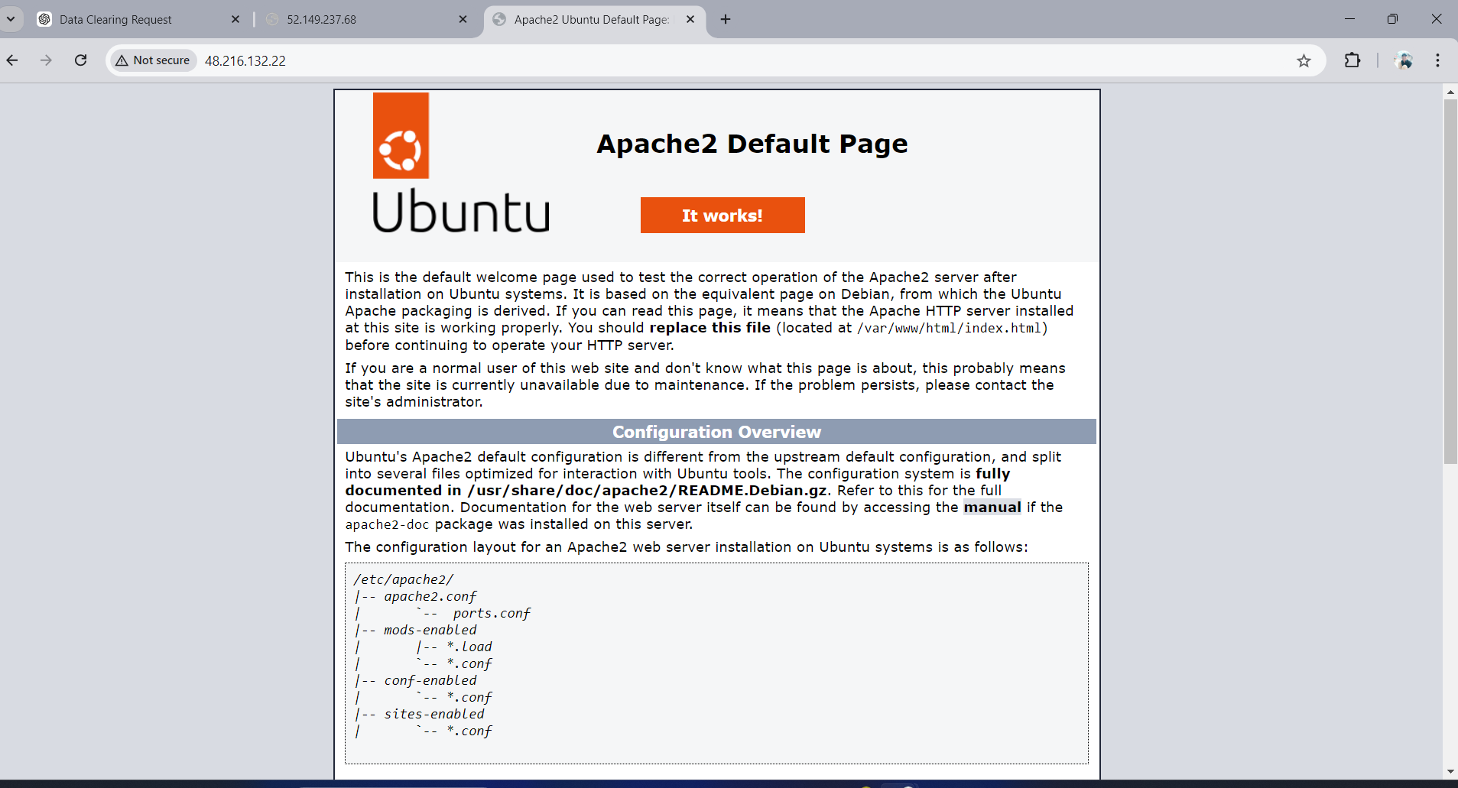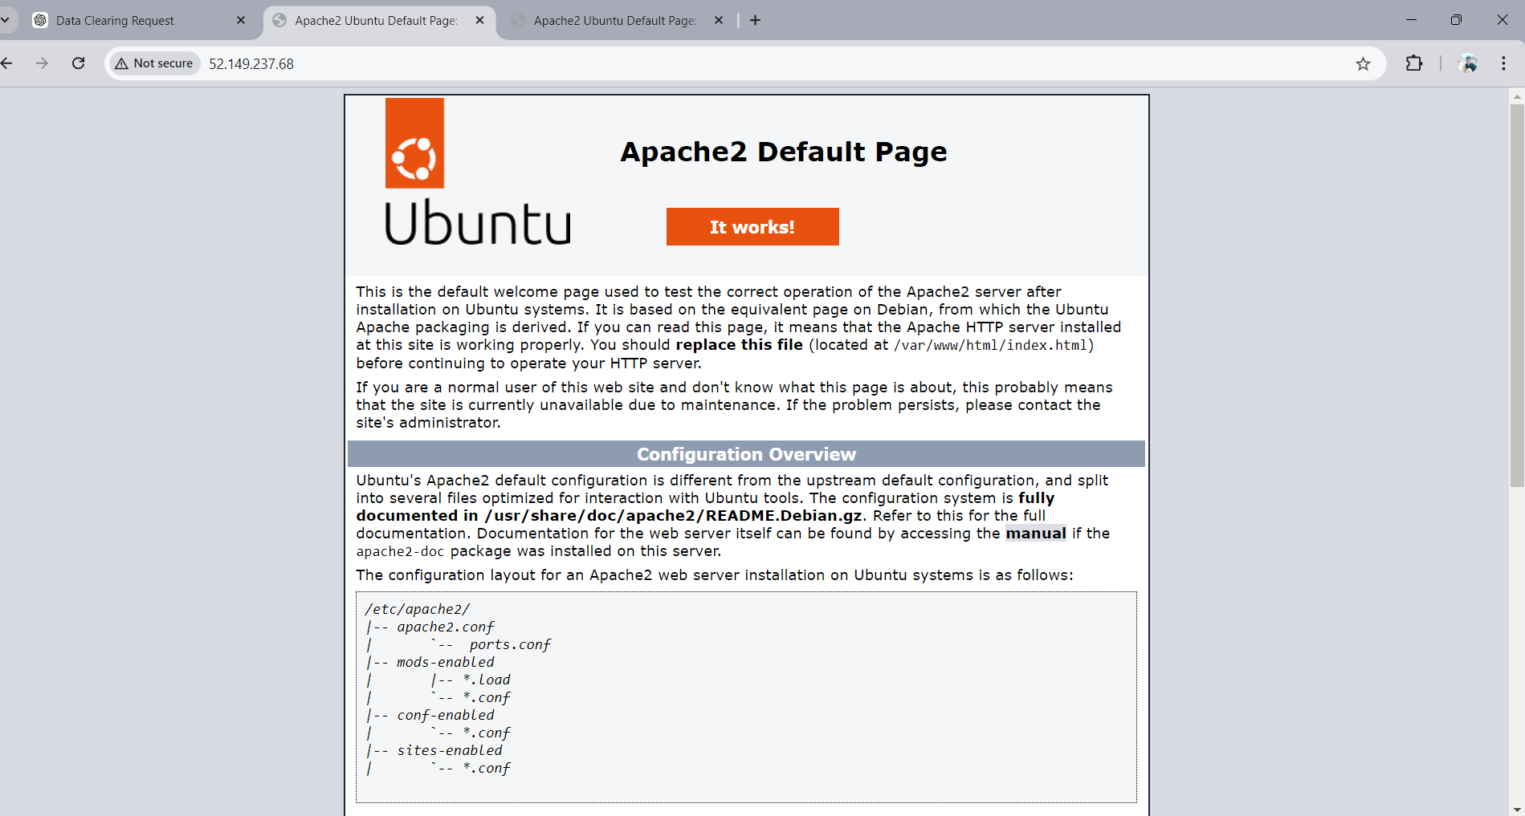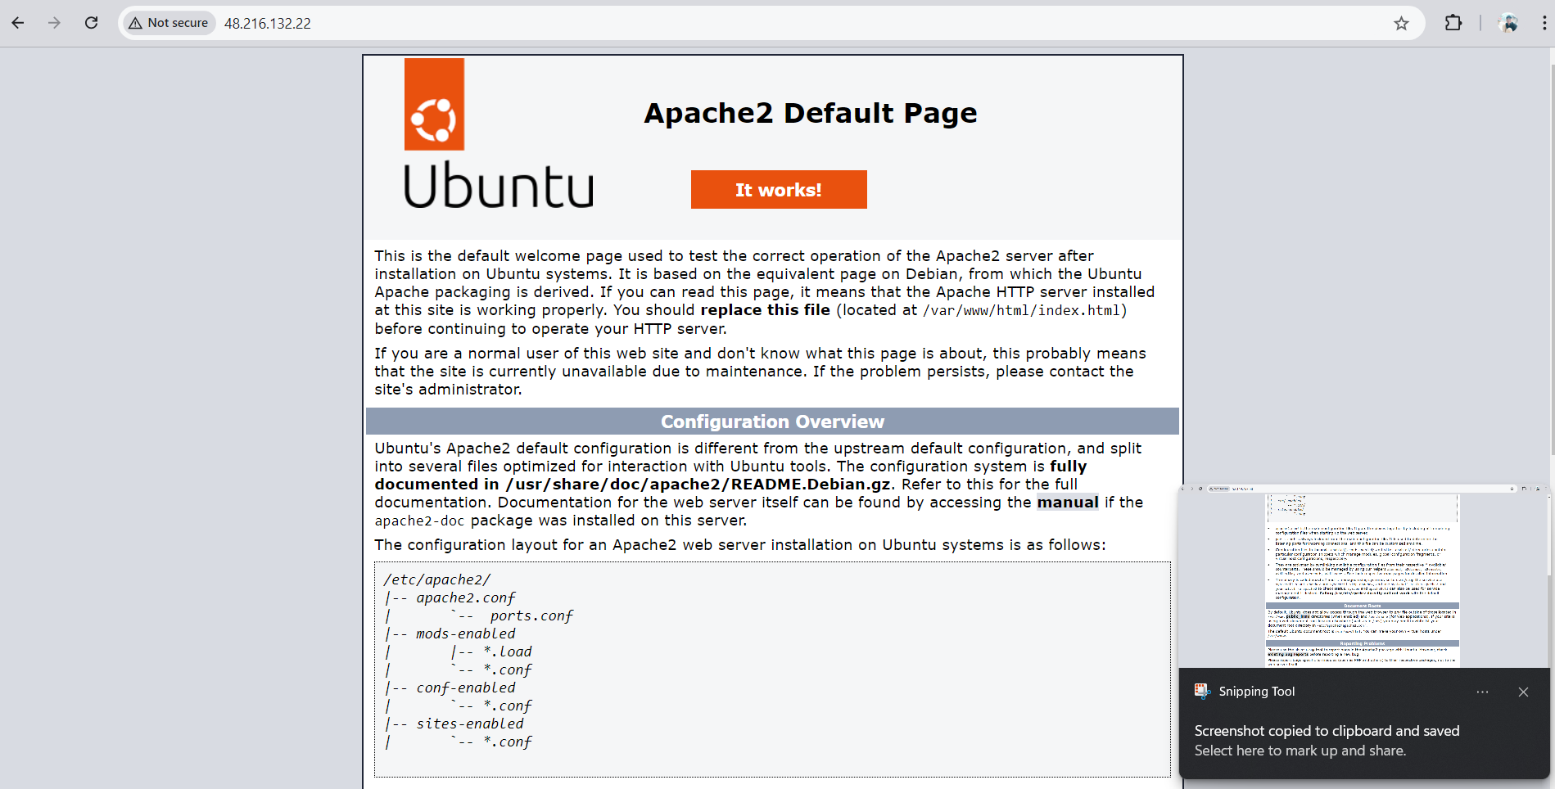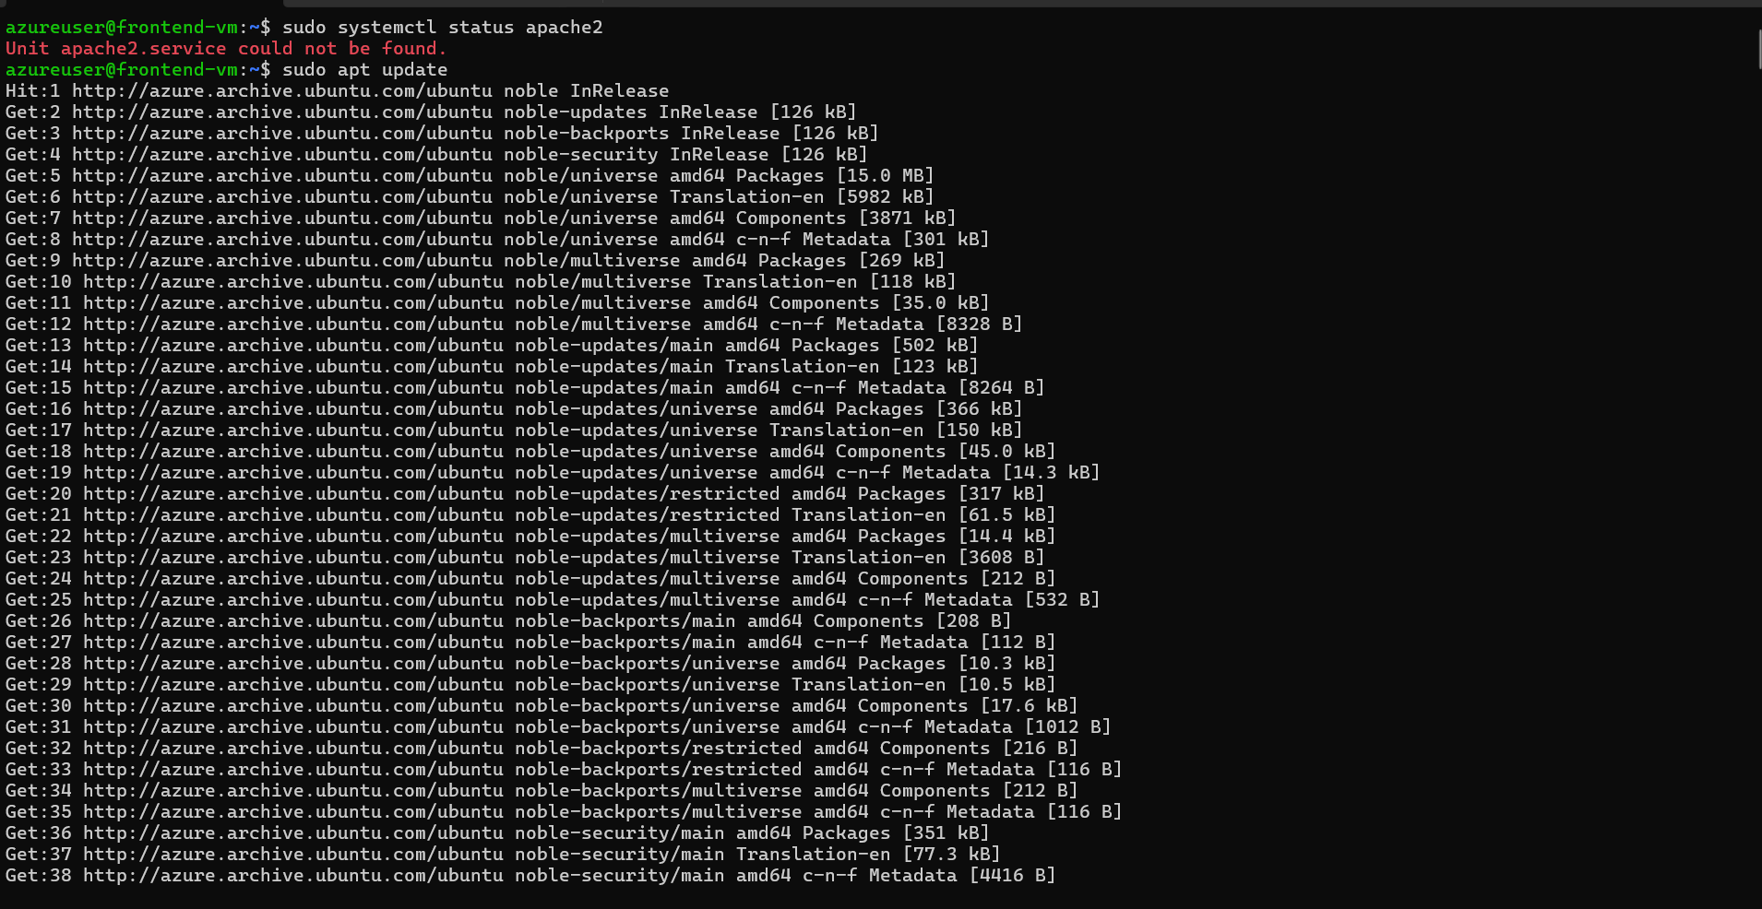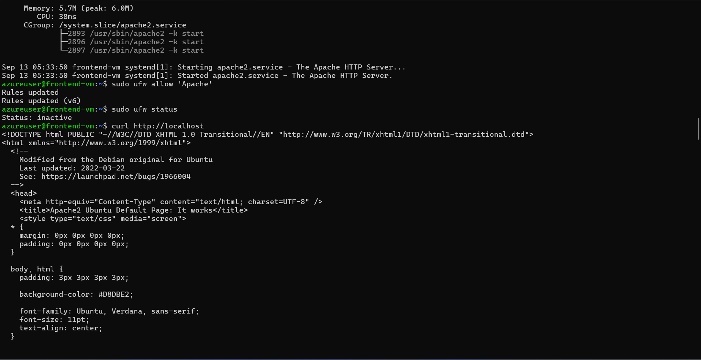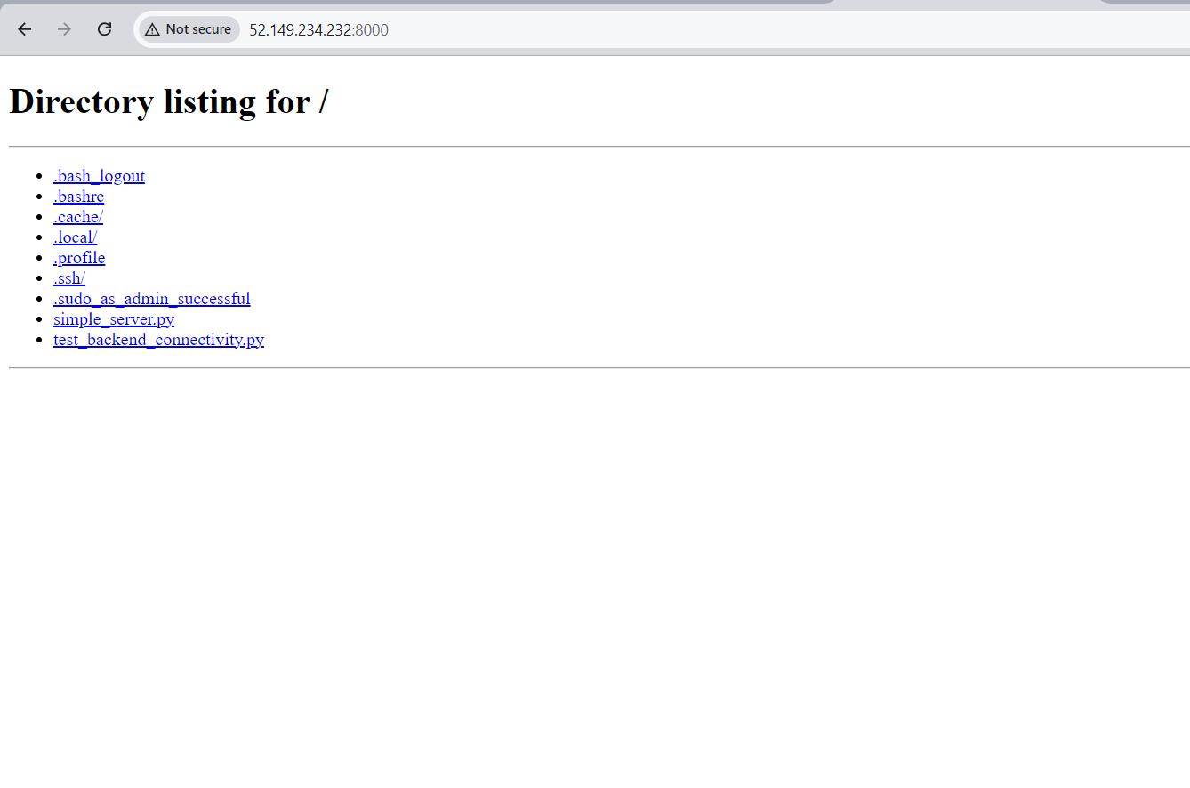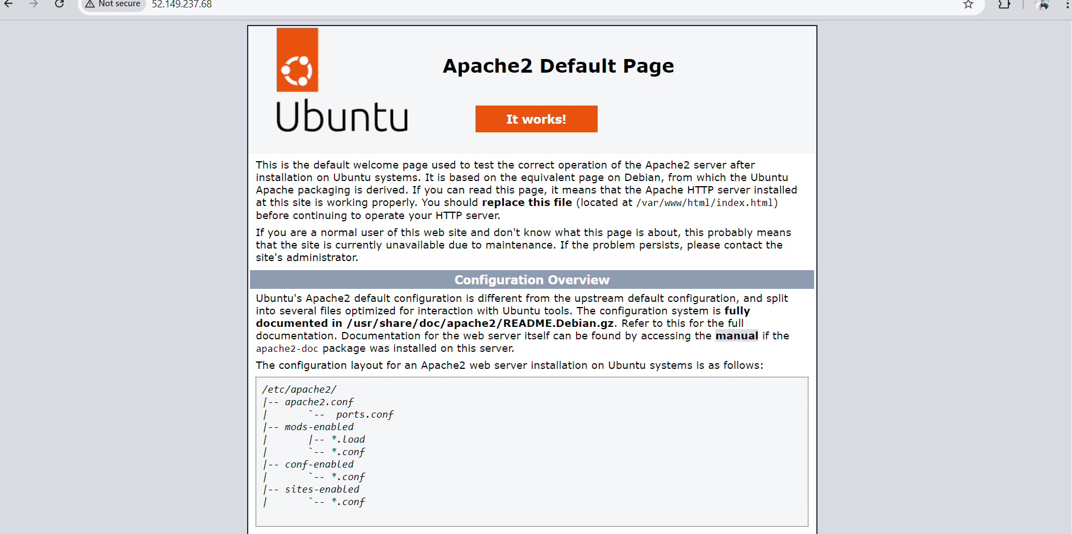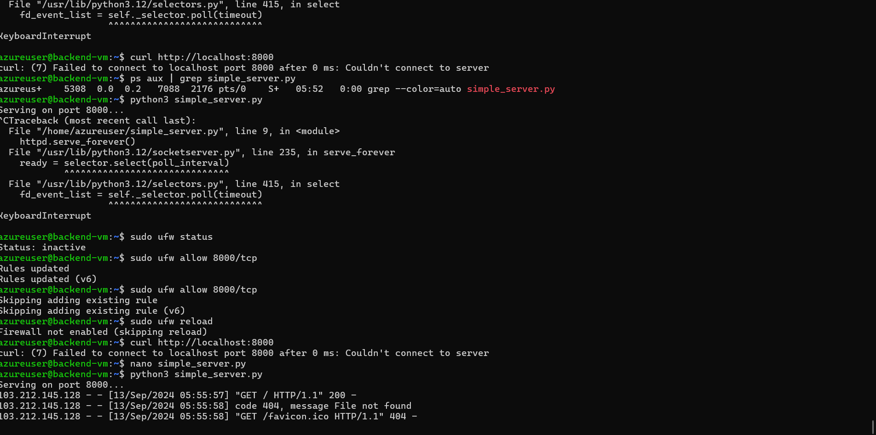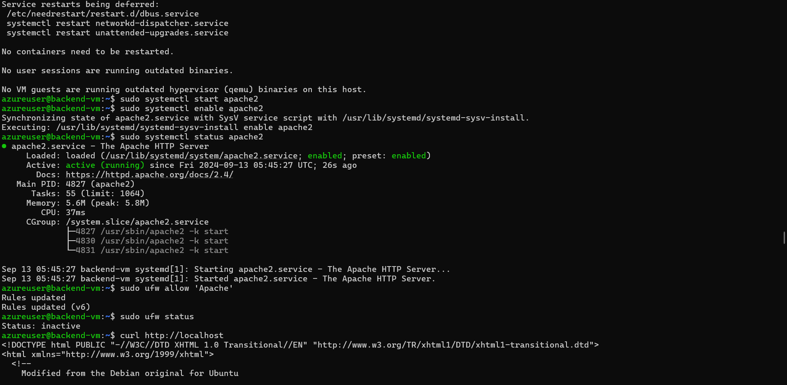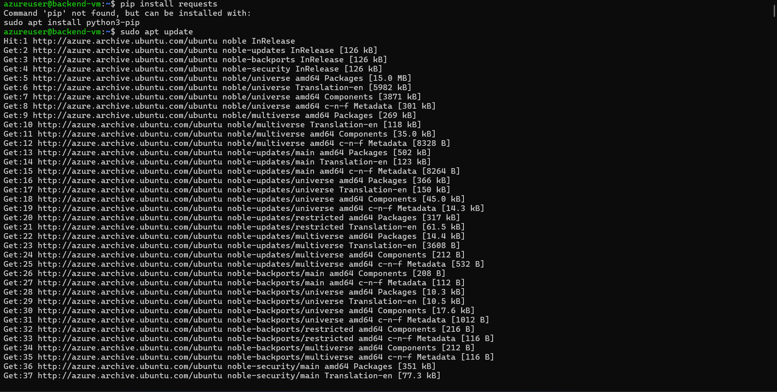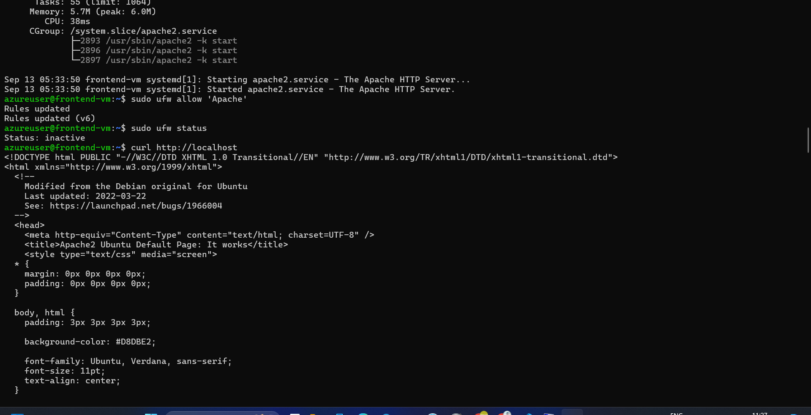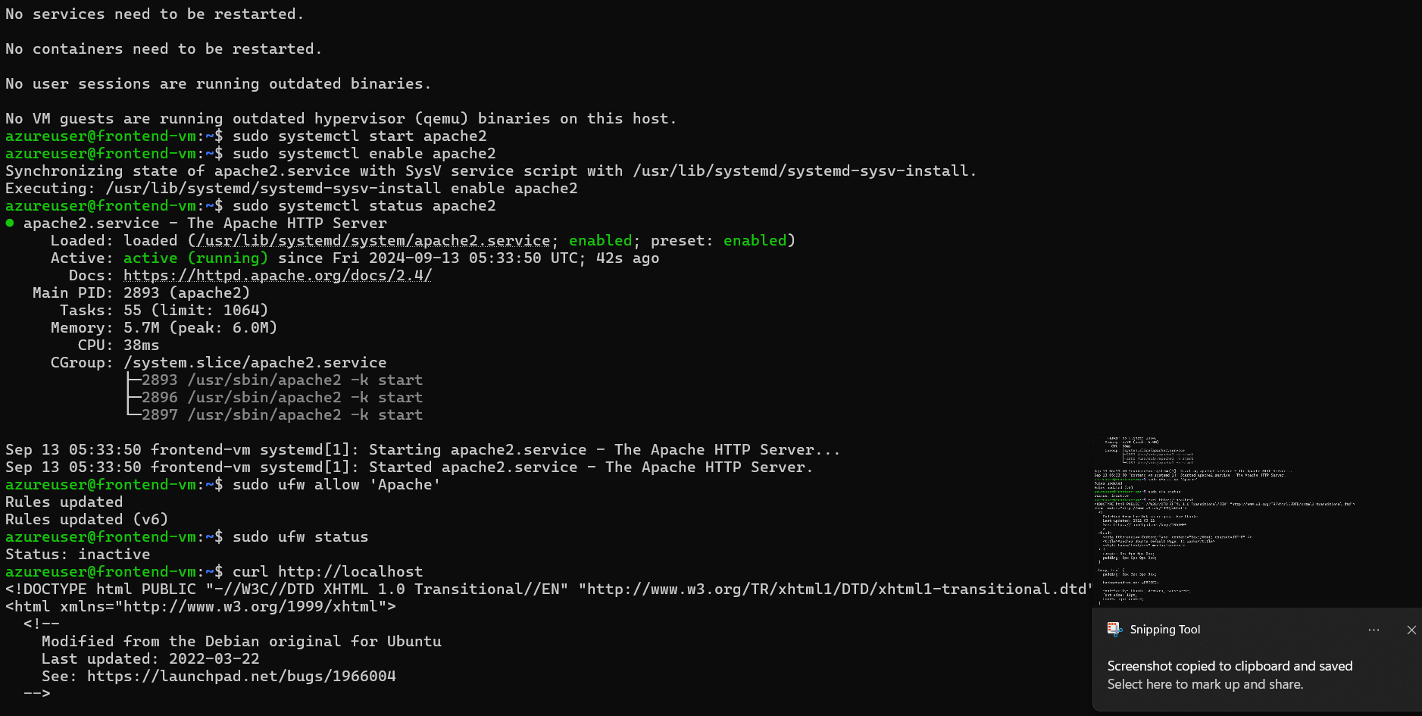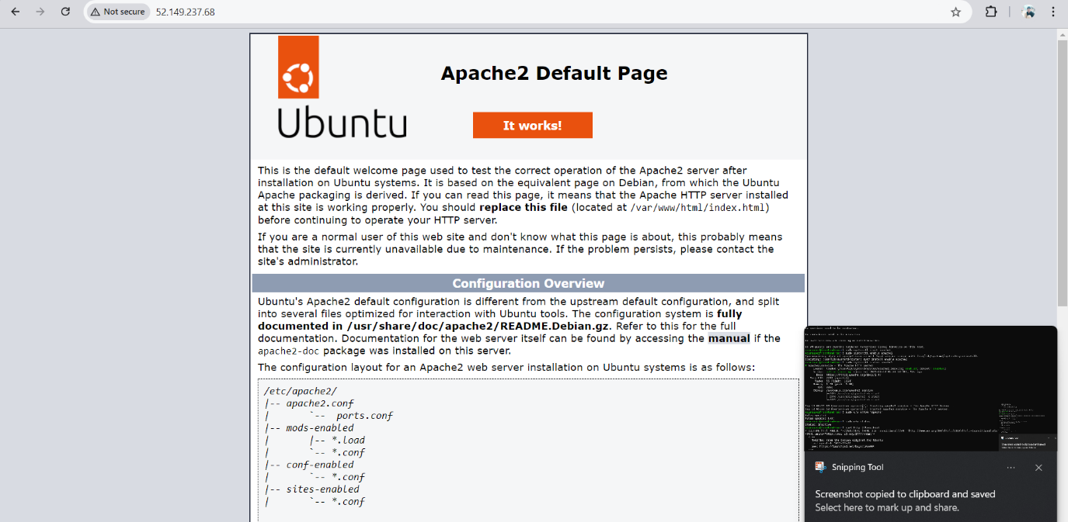

1. Implement **Azure Security Center and Network Security Groups** (NSGs) to protect against external threats. Ensure only necessary ports (e.g., 80/443) are open to the public.

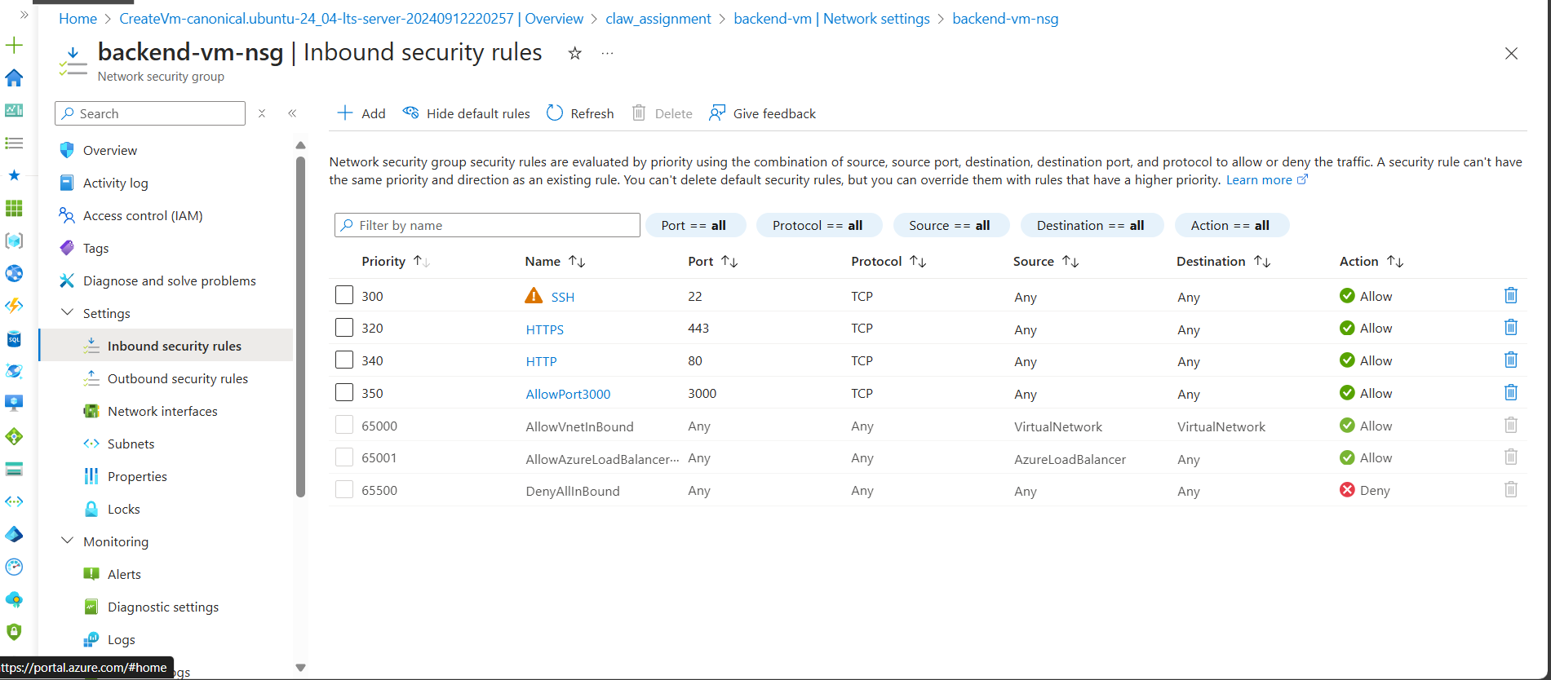

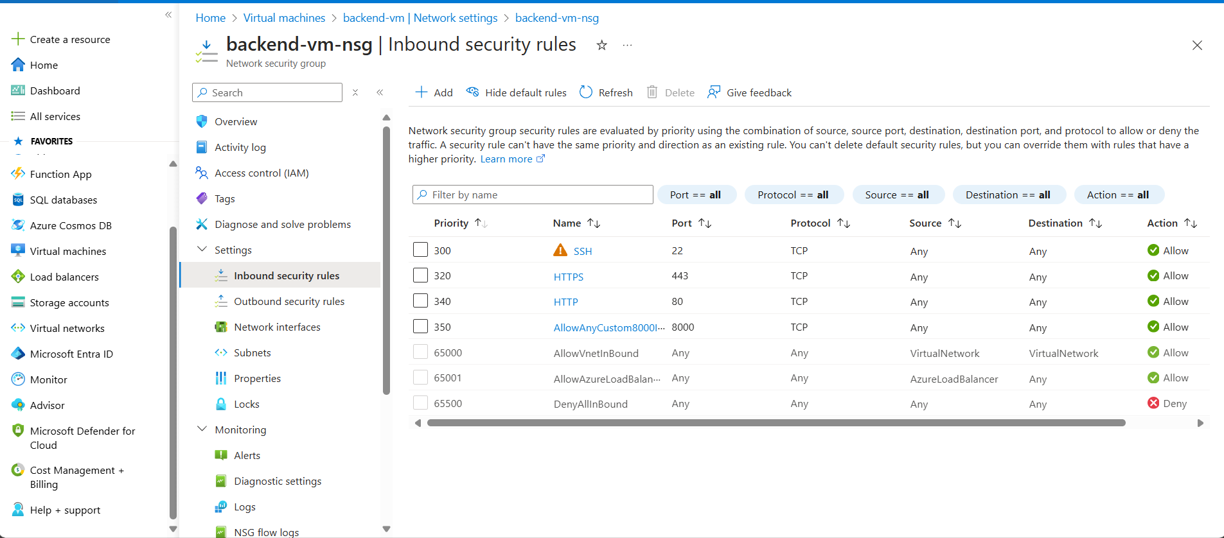

1. Configure a **cron job** on the back-end VM to perform a health check on the database and log the status every 10 minutes.

**onfigure a cron job on the back-end VM to perform a health check on the database and log the status every 10 minutes:** Set up a cron job on the back-end VM to periodically execute a script that performs health checks on the MySQL database. This job logs the database status every 10 minutes, helping detect and address issues promptly, ensuring database availability, and maintaining application performance.

crontab -e

*/10 * * * * /usr/bin/python3 /path/to/health_check_script.py >> /path/to/health_check.log 2>&1

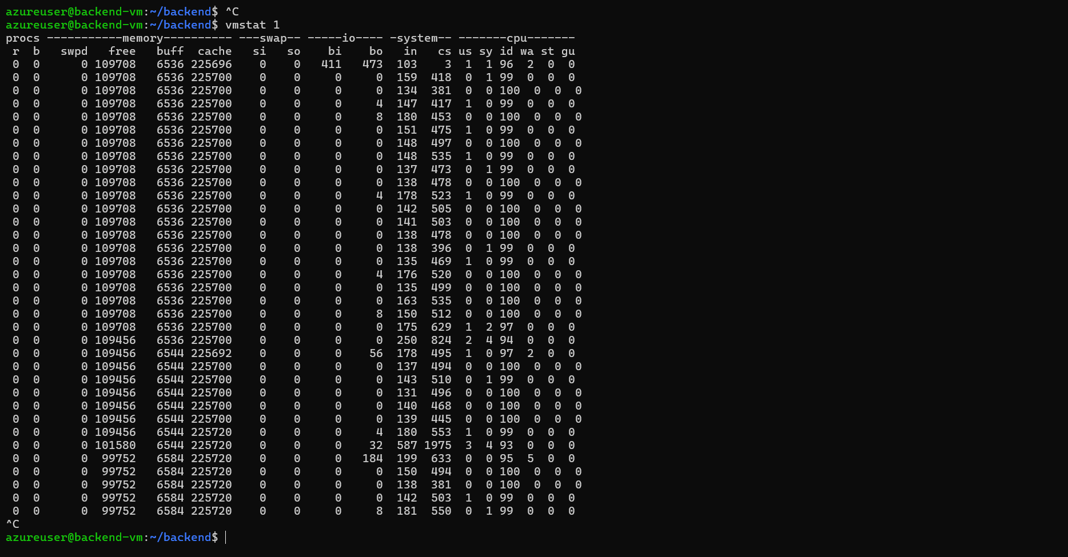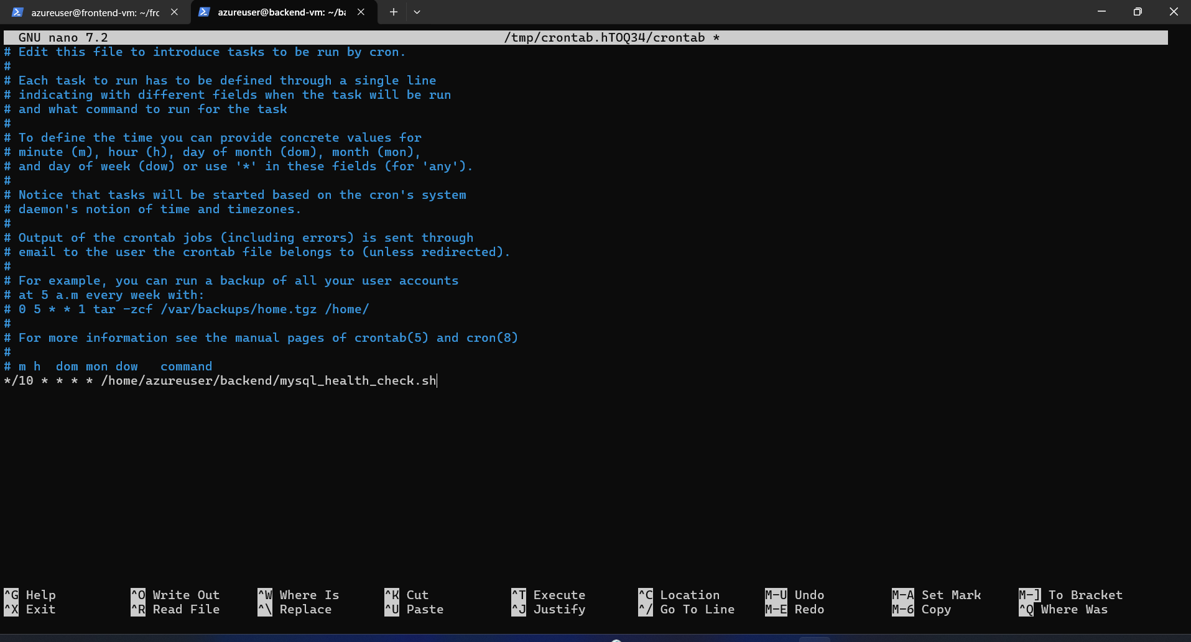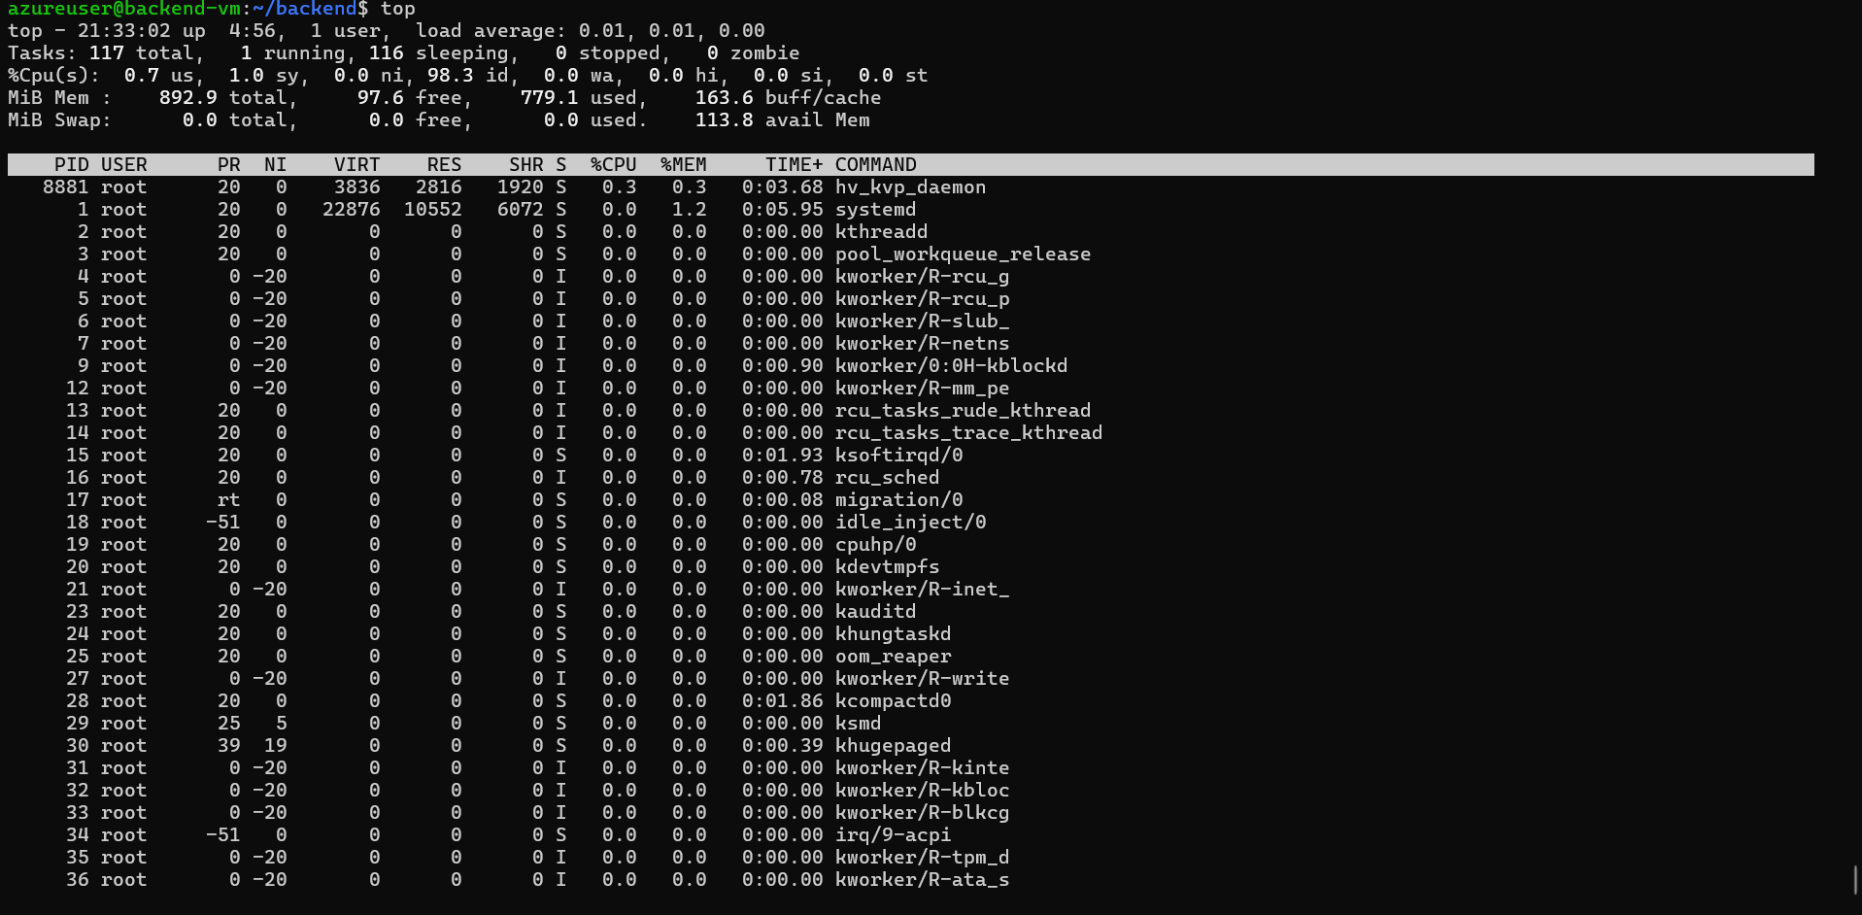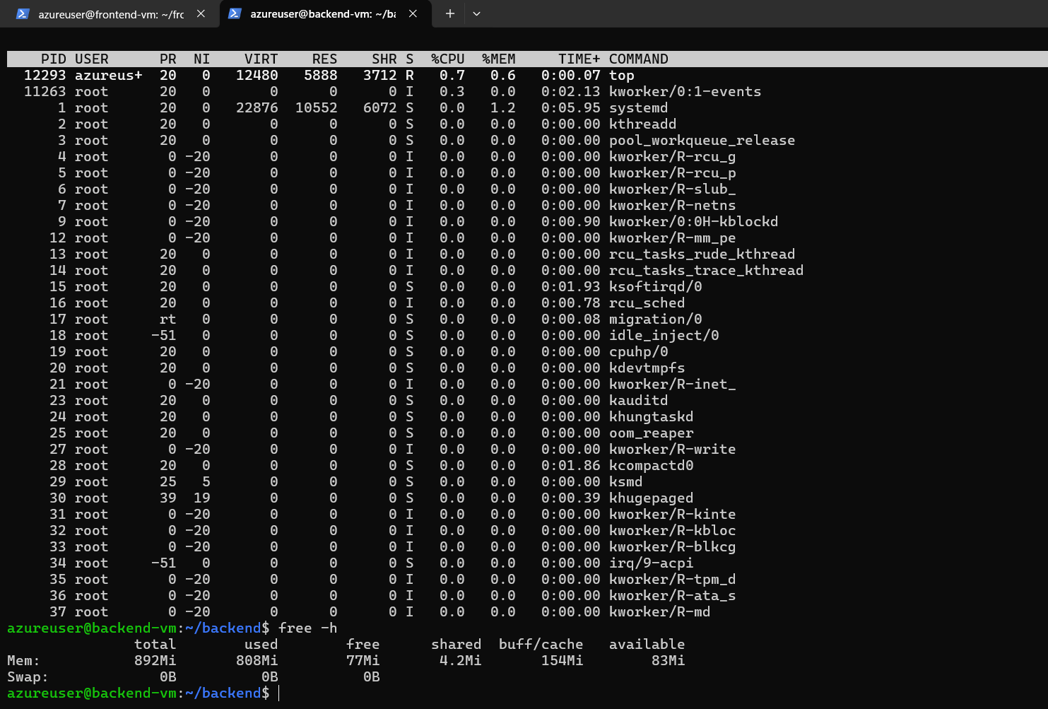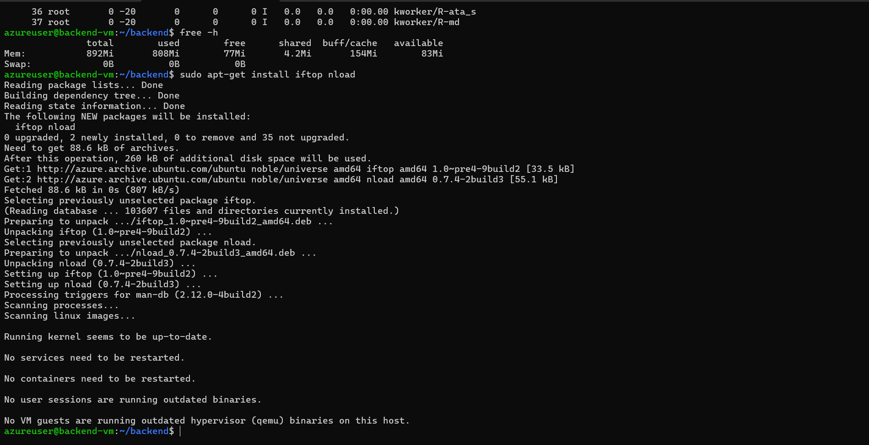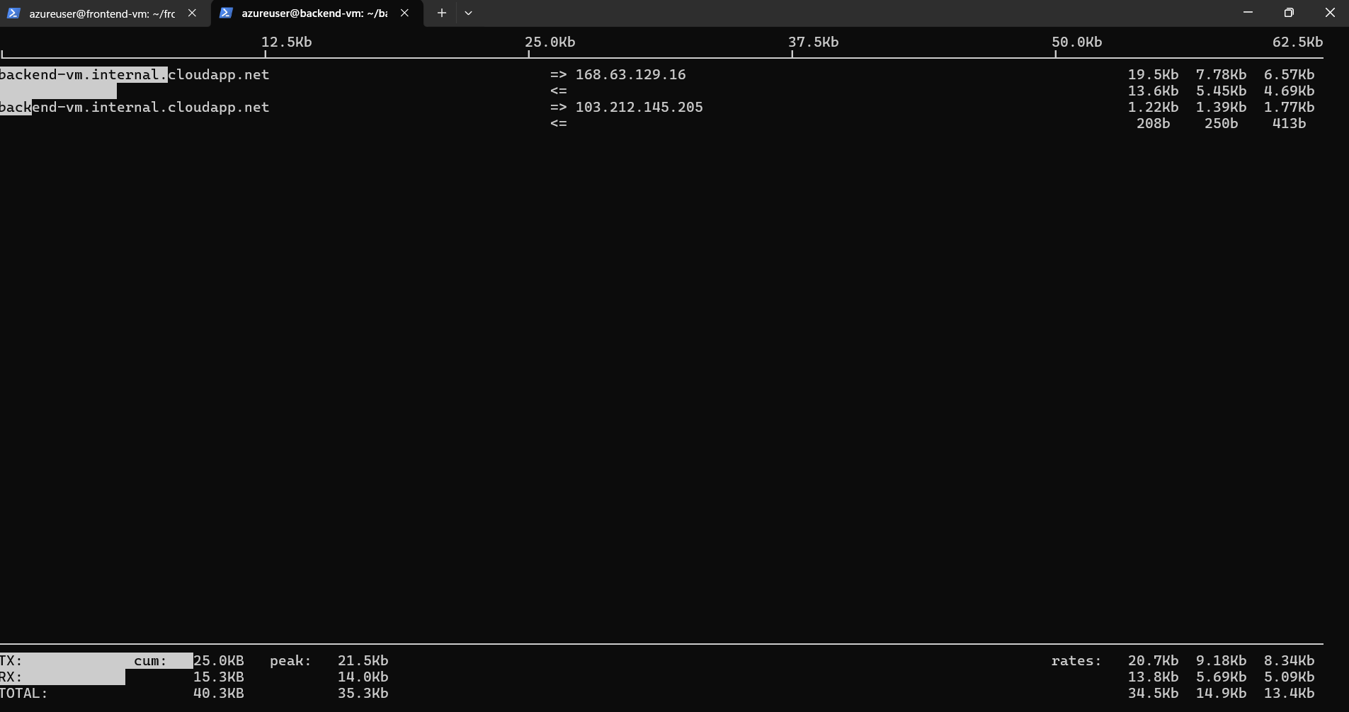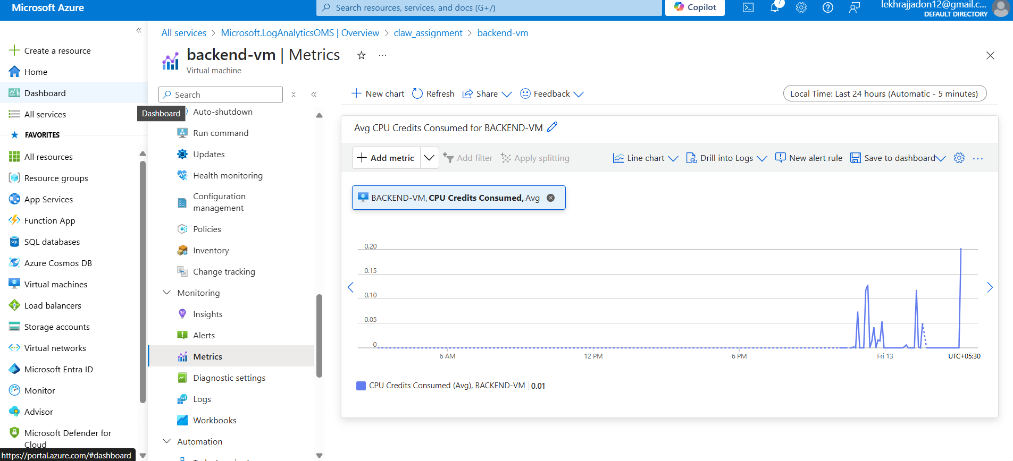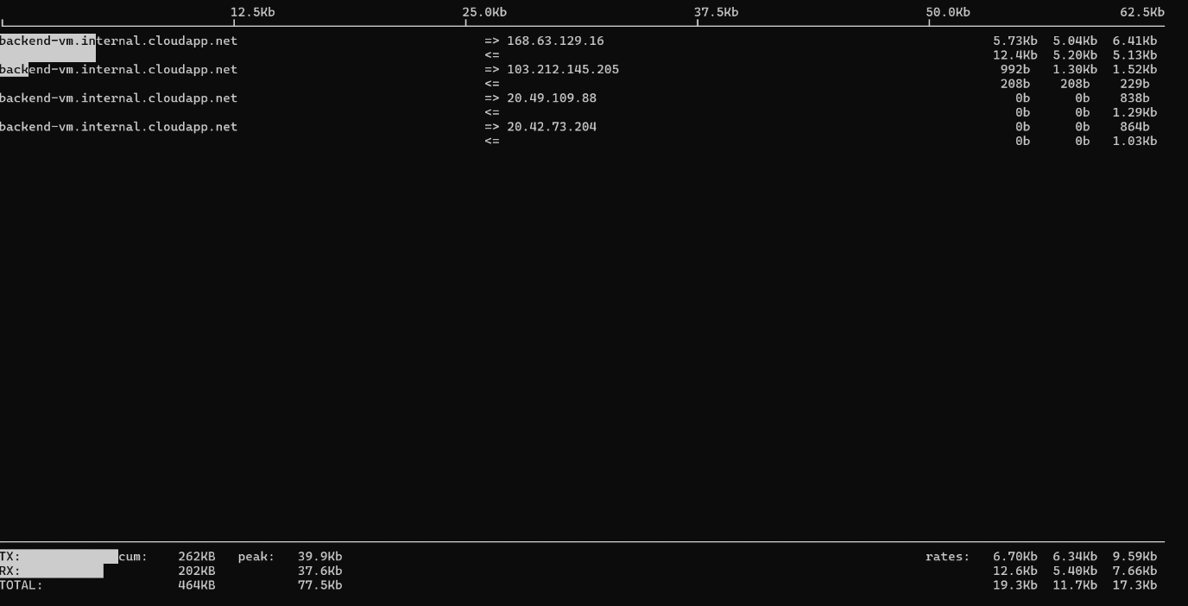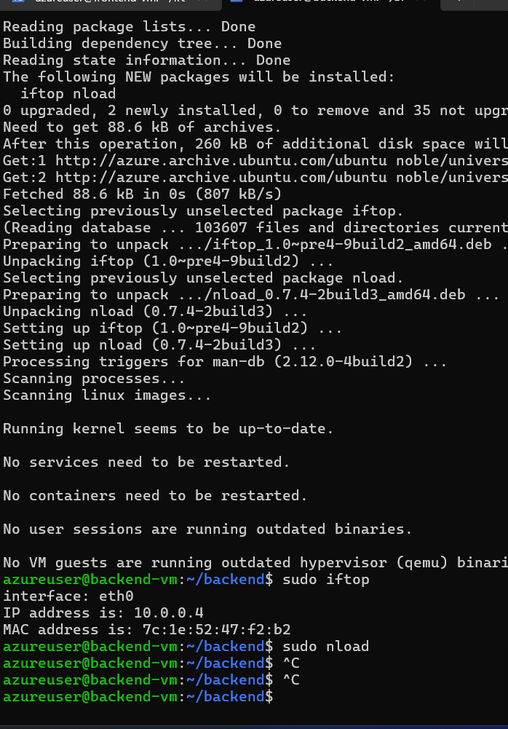

1. **Optimize VM sizing** for cost-effectiveness and performance by evaluating CPU, memory, and network usage.

**Optimize VM sizing for cost-effectiveness and performance by evaluating CPU, memory, and network usage:** Regularly review the resource utilization of your VMs to balance performance and cost. Analyze CPU, memory, and network usage to determine if the current VM sizes are appropriate. Adjust the VM sizes based on the actual workload to optimize both cost and performance, ensuring efficient use of resources while keeping operational costs manageable.

